

**Nishshanka Nimesh Mendis**

2012430

**Mobile Application to Improve Mental Health of Persons with Dementia**

BSc (Hons) Computer Science & Software Engineering

Undergraduate Thesis Report

Department of Computer Science & Technology

University of Bedfordshire

Supervisor: Mr. Vibhavi Attigala

2021 May

# Abstract

Music and videos, according to caregiver anecdotes, play a key role for members of the family diagnosed with Dementia. A widely used mobile interface can be used by dementia patients to display favourite music and family photos through apps created in collaboration with geriatric facilities. Anecdotal evidence suggests that when a mobile computer played their favourite music, nonverbal late-stage dementia patients were stimulated. In addition to offering hard-core evidence for proving improved cognitive ability with technology, there is an unmet demand in geriatric facilities for exciting dementia patients. To improve the quality of living for the cognitively disabled, technology will help close the divide between patients and workers. This research looks into how technology affects people with dementia's cognitive functioning and quality of life. Over the duration of Alzheimer's or dementia, cognition decreases dramatically, leading most patients to be wary of caregivers and, as a result, to be institutionalized. Caregivers are often asked to concentrate their efforts on alleviating the agitation or pain experienced by Alzheimer's disease or dementia patients. Technology instruments such as iPods, cell phones, and laptops have been found to help stimulate people with dementia in studies. This research focuses on cutting-edge technologies such as cell phones, iPods, and tablets, which are widely available and easy to use and can not only help assess the level of dementia but also offer stimulus to improve cognitive ability. The aim of this study is to see whether specially designed applications and current assistive technologies can help older adults with Alzheimer's or other dementia-related disorders reduce their symptoms and enhance their memory. The article delves into the application's characteristics and functionalities, as well as the research and logic behind the system's case. The paper further looks at the event's outcome, as well as the benefits, feedback, and potential work for the application and its users. The article emphasizes the artefact's effectiveness and how it accomplishes its goals and priorities.

The researcher discovered that the chatbot has a better success rate of accuracy, with in the range of 80-90 percent of accuracy showed 60% success rate out of general responses. This importance demonstrates that, in order to achieve a higher accuracy score, the chatbot must also be accurate.

The accuracy of the chatbot and enhancing the available features in the mobile healthcare application, also the researcher planning to add new features to the system, as a future work.

# Acknowledgement

At the outset of this paper, I'd like to thank the University of Bedfordshire for allowing me to participate in this degree pathway.

Next, I would like to express my sincere appreciation to Dr. Enjie Liu and Dr. Gayana Fernando for all of the course materials and guidelines given in this module. Next, I would like to express my gratitude to Mr. Vibhavi Attigala, my research supervisor, for leading me every step of the way and assisting me in effectively completing my research from the beginning. Next, I'd like to express my gratitude to Dr. Tess Crosbie for the session she gave us on day one of this module.

Next, I would like to express my gratitude to Google and Google Scholar for assisting me in locating the research papers and other documentation needed for my research. Next, I would like to express my gratitude to all of the contributors to Stack Overflow, GitHub, the Google Android Developers forum, and the official Google Android Developers YouTube channel, from whom I got invaluable assistance in creating the mobile application.

I would like to thank one of my University undergraduate friend Mr. Dilshan Madhushanka who gave me help to develop chatbot using Python language and backend development of the chatbot.

Then, I would like to express my gratitude to my parents and sister for assisting me in completing this study in such a short amount of time.

Finally, I am overcome with gratitude to those who have driven and shown me the way to achieving all of the research goals by overcoming the obstacles.

# Dedication

This research is dedicated entirely to my parents, who have served as role models in my life. Thank you for never giving up on me and for always believing in me and loving me in every way possible. They have continuously provided me with mental, spiritual, and financial support.

Next, I might wish to dedicate this research to any or all my mentors at UOB and SLIIT.

Lastly, I would prefer to dedicate this project to all or any other members of the family, care-takers, and friends go in the society who are taking care of the persons with Dementia and their best to form the globe a far better place no matter their mental and wellbeing.

# *Key words*

Dementia, Counselling, Application, Alzheimer’s, Relaxation Methods, Music, Artificial Intelligence, Machine Learning

# List of Abbreviation

IDE - Integrated Development Environment

AI - Artificial Intelligence

ML - Machine Learning

WBS - Work Breakdown Structure

UML - Unified Modelling Language

RCT - Randomized Control Trials

CT - Computerized Tomography

MRI - Magnetic Resonance Imaging

IBM - International Business Machines

SPSS - Statistical Package for the Social Sciences

IEEE - Institute of Electrical and Electronics Engineers

SDLC - Software Development Life Cycle

GUI - Graphical User Interface

NLTK - Natural Language Toolkit

NLP - Natural Language Process

API - Application Programming Interface

JSON - Java Script Object Notation

PC - Personal Computer

IP - Internet Protocol

URL - Uniform Resource Locator

Table of Contents

Abstract i

Acknowledgement ii

Dedication iii

*Key words* iii

List of Abbreviation iv

List of figures viii

List of tables ix

Chapter One – Introduction 1

1.1 – Background of the project 1

1.2 – Aims and Objectives 2

1.3 – Description of the artefact 2

1.4 – Structure of the Thesis 4

Chapter Two - Literature Review/Market Survey 6

2.1 – Literature Review 6

2.1.1 – Introduction 6

2.1.2 – Recovery memory using Mobile Application 7

2.1.3 - How Mobile Application Helping for Dementia 8

2.1.4 - How Artificial Intelligence Helping for Dementia 9

2.1.5 - Machine Learning for Dementia 9

2.1.6 – Existing Health care Application for Dementia 10

2.1.7 – Conclusion 15

2.2 – Market Research 16

Chapter Three – Methodology 25

3.1 – Planning and Analysis 26

3.2 – Requirement gathering 30

3.3 – Design and Implementation 31

3.3.1 – Interface Design 31

3.3.2 – Function design 34

Chapter Four – Results and Discussion 39

4.1 – Functions 39

4.2 – Accuracy and Reliability of the System 41

4.3 – Conclusion 42

Chapter Five – Testing and Evaluation 43

5.1 – Evaluation 43

5.1.1 – Functional Evaluation 43

5.1.2 – Performance Evaluation 44

5.1.3 – Test User Evaluation 45

5.2 – Testing 48

5.2.1 – Test cases for Login and Registration 48

5.2.2 – Test cases for Activities 51

5.2.3 – Test Case Chatbot 52

5.2.4 – Test case for To-do list 53

5.2.6 – Test case for Reminders 54

5.2.7 – Test case for Update Profile 56

Chapter Six – Conclusion 57

6.1 - Overview of the Project Background 57

6.2 - Benefits of the system 58

6.3 - Limitations of the System 58

6.4 - Lessons Learned 59

6.5 - Future Work 59

References 60

Appendix 62

Appendix A 62

Appendix B 62

Appendix C 63

Appendix D 64

Appendix E 64

Appendix F 65

Appendix G 66

Appendix H 67

Appendix I 67

Appendix J 68

Appendix K 69

Appendix L 69

Appendix M 69

Appendix N 70

Appendix O 72

# List of figures

Figure 1 - Doctors' questionnaire form screenshot 1 17

Figure 2 - Doctors' questionnaire form screenshot 2 17

Figure 3 - Doctors' questionnaire form screenshot 3 18

Figure 4 - Pie chart of survey Question one 18

Figure 5 - Pie chart of survey Question two 19

Figure 6 - Pie chart of survey Question three 20

Figure 7 - Bar chart of survey Question four 20

Figure 8 - Pie chart of survey Question five 21

Figure 9 - Pie chart of survey Question six 22

Figure 10 - Pie chart of survey Question seven 22

Figure 11 - Bar chart of survey Question eight 23

Figure 12 - Bar chart of survey Question nine 24

Figure 13 - Agile Methodology Phases 26

Figure 14 - Gannt chart 27

Figure 15 - Work Breakdown Structure 28

Figure 16 - Use Case Diagram 35

Figure 17 - Connection establishment with chatbot in Postman 37

Figure 18 - Connection requests received by Postman from POST method 37

Figure 19 - Pie chart of user evaluation question one 45

Figure 20 - Pie chart of user evaluation question two 45

Figure 21 - Pie chart of user evaluation question three 46

Figure 22 - Pie chart of user evaluation question four 46

Figure 23 - Pie chart of user evaluation question five 46

Figure 24 - Pie chart of user evaluation question six 47

Figure 25 - Pie chart of user evaluation question seven 47

Figure 26 - Pie chart of user evaluation question eight 48

Figure 27 - User Registration Test Cases 49

Figure 28 - User Login Test Cases 50

Figure 29 - Memory recall activity Test Cases 51

Figure 30 - Chatbot Test Cases 53

Figure 31 - to-do task Test Cases 54

Figure 32 - Saving Reminders Test Cases 55

Figure 33 - Profile Update Test Cases 56

Figure 34 - Project Poster 72

# List of tables

Table 1 - Frequency table for the survey Question one 19

Table 2 - Frequency table for the survey Question two 19

Table 3 - Frequency table for the survey Question three 20

Table 4 - Frequency table for the survey Question four 21

Table 5 - Frequency table for the survey Question five 21

Table 6 - Frequency table for the survey Question six 22

Table 7 - Frequency table for the survey Question seven 23

Table 8 - Frequency table for the survey Question eight 23

Table 9 - Frequency table for the survey Question nine 24

Table 10 - Test Case one User Registration 48

Table 11 - Test Case two Login 50

Table 12 - Test Case three Memory Recall activity 51

Table 13 - Test Case four Chatbot 52

Table 14 - Test Case five Saving to-do tasks 53

Table 15 - Test Case six Saving Reminders 54

Table 16 - Test Case seven Profile Update 56

# Chapter One – Introduction

This a part of the thesis will entail the complete background of the project and analytical thinking for the implementation and development of the concerned framework. This further comprises the aims and objectives and emphasizes the features of the proposed system. At last, the section explains the layout of the next divisions within the thesis report.

## 1.1 – Background of the project

The proposed project is to develop a mobile application for people with Dementia and Alzheimer's. Dementia is recognized as one of the growing social health problems among older people in society. This is not a problem for the individual concerned, but it causes stress to the family members, neighbours, friends, and others who are involved in supporting a person with Dementia. Dementia is caused by abnormal brain changes, damage to or loss of never cells and their connection in the brain and communication problems, a change in personality, and a reduce ability to carry out daily activities such as washing or dressing. Depending on the area of the brain that is affected, they may face experiences in short term or long-term memory loss. It may lead to physical malfunctioning and disability too. Simply the drugs do not use for these people to improve their mental stability but if the patient is risk of harming themselves or others, they must seek medical attention to take drugs. Otherwise, doctors recommending for music sessions and sound therapies.

Since this is a modern era there is a strong relationship between human and information & communication technology. By using information technology, it can develop solution applications. This proposed project will help people with dementia maintain and improve mental functions. Since persons with Dementia have difficulties in concentrating, their span of attention is low, and they project irregular behaviours. Due to this reason, the caretakers find it difficult to handle them. Here the researcher can build their attention through calm sounds such as water flowing, the sound of birds, playing soothing music to calm them down, and have a conversation about that sound and what they heard. From the beginning by studying the patient’s behaviour and output, the researcher can get to know his or her likes, dislikes and interest to develop a successful application to improve their concentration and span of attention. For that, the researcher needs to provide activities to remember things, ask questions about their past and what they remember without giving any sort of pressure or stress to the patient. By using attractive colours to the user interface, the system can draw the patient’s attention to the device.

## 1.2 – Aims and Objectives

**Aims**

* To Develop a mobile application to improve mental health and quality of life a person with Dementia.

**Objectives**

* To Identify the patient’s attributes properly relating to Demetria which is suitable to the patient.
* To implement a neural network which predict the range possibility of Dementia level.
* To develop a mobile application to map simple tasks to complete to get the attention of the patient.
* To evaluate the proposed system with current mental health application
* To implement an artificial intelligent chatbot function which is help user to manage their tasks and daily activities easily.

## 1.3 – Description of the artefact

The proposed system is an application helps for the people with Dementia to increase their thinking ability and recognizing or remembering any object. This proposed system called “DementiaCare” This is entirely a mobile application developed based on the Android version 4.0 or above with 1GB ram or above and also with 2 GB secondary storage.

**Features of the system,**

* User registration / Login

Before using application, user needs to make a profile by entering personal data such as age, description of medical condition and other than the user’s identity information. All the users get a unique id from the backend database (Firebase). While the successfully registered user navigates to the dashboard. After user logout from the system and login to the system once again user has to provide user email and user registered password and after that user has to tick a checkbox where provided in login interface. Once the option is put a tick even though the user closes the application the user doesn’t need to provide login credentials after application opens.

* Displaying user details / View User profile

In here, user needs to see their user details such as name, age, and other details of them. User also can update their user details successfully by clicking a button

* Recognizing objects

After successful login proposed application provides simple activities or tasks such as recognizing objects such as shapes, colour of some object and size of any object. This is helpful to improve user’s logical side of thinking.

* Memory recall

Further user can face activities such as remembering simple letter and repeat asking the letter after few seconds. This will help to find out their memory with their responses.

* Music

Most therapists follow this step to calm down the patients. Sometimes this helpful to gaining memory, some incident happened to their lives. The system can have ability to recall their memory from that. System itself provides songs playlist with contains 8 low beat slow flow songs along with a media player inside the developed application

* Soothing sounds

The researcher’s main target is to keep the patient calm without give any pressure to their minds. Because of their mental stability they might cannot here sounds which disturbing to them. In this part mainly consider about what they here. Sounds such as sound of birds, sound of water droplets or water flowing and other non-disturbing sounds. System provides music tracks user can listen to those tracks after they install the application.

* Reminders

The researcher developed the reminders feature for the user to save their reminders for a particular time and in a particular date. All the reminders saved by the user stores inside the device storage until the reminder is complete. System also provides Google talk function inside reminder. User can save their reminders using voice commands without typing. After saving the reminder notification will display on device notification panel. User cannot clear that notification until the reminder is completing. The notification won’t disappear after application closes from the recent applications.

* To-do list

Researcher developed to-do list function inside the developed application where user can save tasks and all the saved tasks saved until the task is complete. User can insert, update and delete tasks whatever user needs to proceed actions.

* Games

This feature helpful to the users to improve the logical thinking and improve memory to user to take decisions.

* AI Chatbot

This is the research component feature which has been developed by the researcher. The researcher lately decided to add this feature with the help of the supervisor. The researcher hopes this feature will help users to ease their tasks and daily activities.

## 1.4 – Structure of the Thesis

This section organizes the topics in a hierarchical order to reveal the thesis's content flow.

1. Introduction
2. Literature Review/Market Survey
3. Methodology
4. Results and Discussion
5. Testing and Evaluation
6. Conclusion

The Introduction chapter of the thesis contains a description of the project creation, core features of the project, primary functions, goals and priorities, and an outline of the artefact to help readers obtain a thorough understanding of the thesis study.

The methodology also includes chapters on literature and analysis, which offer a broad description of the marketing study and literature review process. As a result, it progresses through the stages of current structure testing and study in comparison to the agreed framework.

The methodology chapter describes the methodology that was used to create this strategy. Since the project was only supposed to last seven to eight months, it was able to finish the artefact in fast sprints. The look method, requirements, and gathering processes are addressed in order, as well as the design and execution phases, as well as the UML diagrams associated with the project. In addition, the other methods used during the creation process are discussed.

Results and Discussion, with the help of the attachments, this section summarizes the final word lead to each stage and addresses the performance, power, and vulnerability of the assigned project in the execution and progress process.

When heading to the Assessment and Evaluating section, it outlines how to assess and evaluate the planned application, as well as the test cases that are used to correctly predict the event's performance.

Finally, the project's conclusion announces the thesis summary, stressing the negatives and benefits of the production. It also outlines longer-term projects and recommendations that will be implemented in the future in relation to the proposed framework in order to boost productivity even further.

# Chapter Two - Literature Review/Market Survey

A proper literature review linked to mental health of people with Dementia, the impact of it for the society and to individuals and the solutions given so far will be provided in this section. The importance and the reasons for the researcher to undertake the research will be highlighted in this section. Then the researcher liked to discuss how the Information technology based mobile application will affect to persons with Dementia.

## 2.1 – Literature Review

### 2.1.1 – Introduction

All the areas required for the research of this proposed topic is covered in this literature review. What is Dementia, what causes of Dementia, impact of people with Dementia, what are the medical treatment that doctors’ preferring and how mobile application is helpful to recover their memory for it is discussed under this chapter Market research was carried out in the aid of pointing out the importance of this research. The latter part of this literature review concentrates on the similar systems which are critically evaluated. For the similar systems researcher decided to choose Android and iOS applications which most users are using these two operating systems around the world.

#### 2.1.1.1 – What is Dementia?

Dementia is a loss of mental functions that is severe enough to affect your daily activities or routines and functions such as memory, language skills, visual recognition, problem solving, trouble with everyday tasks, ability to focus and pay attention *(U.S. National Library of Medicine, 2020).* The researcher explains more information under Appendix A.

There are several common types of Dementia which is explains more information under Appendix B and the factors which cause of the Dementia is given in Appendix C.

Generally, dementia experiences these stages. However, it might fluctuate contingent upon the region of the cerebrum that is influenced. The researcher explained stages under the Appendix D.

#### 2.1.1.2 – Impact of people with Dementia

The researcher explains further details under Impact of people with Dementia is discussed under Appendix E.

#### 2.1.1.3 – Counselling and Therapy

Persons with Dementia is main thing is to follow counselling a doctor to seeking advices. Counselling and therapies are discussed under Appendix F.

#### 2.1.1.4 – Relaxation and Recovery methods

In this section researcher discussed about the relaxation methods which relevant to persons with Dementia. The researcher explains relaxation and recovery methods under Appendix G. According to the research there are two main therapies which is approved by doctors. One recovery method is music therapy. The researcher discussed about music therapy under Appendix H. Another method to recover is brain exercises which doctors are following to recover memory of persons with Dementia. Further details discussed under the Appendix I.

### 2.1.2 – Recovery memory using Mobile Application

#### 2.1.2.1 – Introduction and Background

Versatile applications are programming programs living on a compact gadget, for example, a cell phone, watch, or tablet. Favourable circumstances of application innovation for treatment conveyance incorporate its straightforward entry to data, the capacity to convey home practice activities, for example, sound chronicles, capacity to send notices and updates, and potential to catch dynamic and aloof use criticism. Applications may house data accessible for disconnected use, interface with sites, or both. Applications with data accessible disconnected might be obviously appropriate for the conveyance of treatments that give standard home practice practices so parental figures do not have to associate with the web each time they wish to utilize them *(Sikder, A.T., Yang, F.C., Schafer, R., Dowling, G.A., Traeger, L. and Jain, F.A., 2019)*.

The utilization of the Internet is quickly expanding around the world, including among more seasoned grown-ups, and can possibly be a powerful method of conveying mediations to help family guardians of individuals with dementia all through the providing care measure *(Boots LMM, de Vugt ME, van Knippenberg RJM, 2014)*. A few ongoing meta-examinations of Randomized Controlled Trials (RCTs) on Internet mediations for more youthful objective gatherings with side effects of gloom or tension have indicated that these intercessions can possibly be (cost)effective *(Hedman E, Andersson E, Lindefors N, Andersson G, Rück C et al, 2012)*. From the purpose of view of family guardians themselves, Internet backing may have some preferences contrasted with vis-à-vis uphold. Individuals can partake in a web course at the time that is generally appropriate for them; they do not have to head bent a medical aid proficient, which spares time; and Internet backing can be simpler for them to acknowledge see able of the shame related with searching for help from an expert (emotional wellness) care supplier *(Blom MM, Bosman JE, Cuijpers P, Zarit SH, Pot AM, 2013)*. Be that as it may, until now, results from RCTs on Internet mediations to decrease the mental manifestations of guardians of individuals with dementia are still scant *(Boots LMM, de Vugt ME, van Knippenberg RJM, 2014)*.

In this unique situation, the help of innovation offers a lot of potentials and can improve the personal satisfaction of individuals with dementia and their casual guardians *(B. C. Zapata, J. L. Fernández-Alemán, A. Idri, and A. Toval, 2015)*. Late activities in smart gadgets (i.e., smartphones, versatile workstations, tablets, and so on) have made portable applications a promising hotspot for connecting with individuals in medical services *(K. Yousaf, Z. Mehmood, T. Saba et al, 2018)*, especially persons with disabilities with high medical service’s needs *(B. Klimova, 2017)*. Researchers demonstrated that persons with disabilities can utilize touchscreen gadgets effectively, and this innovation can give a wide scope of advantages to them and their guardians. It makes a significant open door for engineers to convey an important application by adding drawing in exercises for such individuals to carry on with their life more autonomously *(D. Hitch, J. Swan, R. Pattison, and R. Stefaniak, 2017)*.

### 2.1.3 - How Mobile Application Helping for Dementia

Dementia is one of the most difficult diseases in older adults, affecting not just the people who have the disease but also their nonprofessional or informal caregivers. It is a dynamic condition characterized by a gradual loss of cognitive abilities such as understanding, recalling, and reasoning (Zahid Mehmood, Tanzila Saba, 2019). Further Zahid and Tanzila mentioning that the use of technologies to help people with dementia and their informal caregivers has a lot of promise and can increase their quality of life.

According to research, there is no treatment for this fatal illness. However, by improving the patient's quality of life and offering a cure for strengthening the patient's cognitive capacity, the disease's development can be delayed (Gaurav Gupta, Ankit Gupta, 2019). Further Gaurav and Ankit state one potential remedy is to encourage the patient to use his or her smartphone. Smartphones are important for Alzheimer's patients' families because they assist them in carrying out their daily lives by sending them updates on a regular basis. Furthermore, Gaurav and Ankit say the smartphone aids the caregiver in providing adequate treatment to the patient by retrieving the patient's GPS position via Geotagging. Photographs can be used as a way to help patients recall their loved ones.

### 2.1.4 - How Artificial Intelligence Helping for Dementia

Artificial Intelligence is reshaping the world of computational services and user engagement in a variety of ways. Huge amounts of data are becoming useful for feeding intelligent systems that analyse, understand, and offer insights, as well as assisting decision support systems. Machine learning and the application of algorithms are critical for extracting functionality, reasoning over gathered data to make it usable and preventive, and revealing findings that add to our understanding of structures and processes (Fernando Luís-Ferreira, João Sarraipa, 2020).

Dementia impairs a person's capacity to perform everyday tasks when he or she becomes overwhelmed and forgets the order of steps to follow. The current approach is for the client to be constantly supervised and assisted by a caregiver who uses audible instructions or cues (Alex Mihailidis, 2010). Further in his (Alex Mihailidis) article he proposes that this condition may be changed by using a computerized device that tracks progress and sends out necessary updates. His proposed system was a prototype called COACH. This device utilizes artificial intelligence to track a person, learn from their behaviour, and issue pre-recorded cues with differing levels of information. The device was created with the help of a computer and a video camera that monitored the user invisibly. Preliminary experiments with participants who simulated confused actions while washing their hands revealed that the system was 95% successful in executing its functions.

### 2.1.5 - Machine Learning for Dementia

Early detection may postpone or prolong the onset of dementia, which is the most common degenerative condition in seniors (Aram So, Danial Hooshyar, 2017). In this research, they used machine learning methods to propose a two-layer model inspired by the approach used in dementia care centres for early dementia diagnosis.

There is currently no successful cure for dementia that will delay or hinder its development. The importance of focusing on the disease's early stages, prompt diagnosis, and delay cannot be overstated. Dementia is diagnosed clinically based on a patient's and family's extensive psychiatric records, a neurological assessment, and neuropsychological evaluations. To rule out any causes of dementia, additional examinations such as haematology, CT, and MRI should be done (Fubao Zhu, Xiaonan Li, 2020).

The exponential growth in the availability of digital records has necessitated advancements in automated text classification. Machine learning (ML) algorithms can ‘learn' from data: for example, an ML method can be trained on a collection of features obtained from written texts belonging to known categories and learn to differentiate between them (PeterGarrarda, VassilikiRentoumia, 2014). In recent years, neuroimaging combined with computer-assisted algorithms has made significant progress in solving this issue. The use of machine learning algorithms for neuroimaging is largely responsible for the effectiveness of these methods (Yuan Zhang, Zhiquan Feng, 2018).

### 2.1.6 – Existing Health care Application for Dementia

#### 2.1.6.1 – Introduction

Smartphones advancements are ideal for medical services intercessions since they incorporate various capacities, for example, Internet access, portable media transmission, sensors, warnings, and the capacity to introduce applications that are clinically engaged *(Putzer, 2012)*. Indeed, versatile innovations have been demonstrated to be a viable way to deal with wellbeing observing for grown-ups with changing ongoing ailments *(Hardinge et al, 2015)*. the survey additionally revealed that advanced mobile phone applications have been appeared to help persistent consideration in psychological wellness settings for conditions including psychosis/schizophrenia, despondency, bipolar confusion, and substance misuse. Such innovations have demonstrated adequacy in checking tolerant symptomology, encouraging patient self-administration, screening patients for melancholy, and giving a subordinate to talk treatment. Cell phones likewise have shown to be possibly helpful for evaluating psychological capacity in more established grown-ups *(Ellen Leslie Brown, Nicole Ruggiano, Juanjuan Li, 2017)* also, conveying customized memory treatment *(Zhang & Ho, 2017)* and, the early examination is as of now looking at the utilization of cell phone innovations for correspondence treatment in people with neurological issues *(Ireland et al, 2016)* and to assist with security observing for more seasoned grown-ups *(Sun et al, 2014)*.

Under given existing Android an iOS applications, the researcher personally downloaded from Google Play Store and iOS App Store and the researcher got user experience from each application and plan to discussed pros and cons as a summary under the conclusion section final part of this literature review.

#### 2.1.6.2 – Android based Applications

The researcher decided to select and discussed about similar systems to which has highest user reviews on Google Play store.

##### 2.1.6.2.1 – Cognicare – Support for Dementia Care

Cognicare is a mobile application which was developed by **CogniHealth Ltd** falls under **Health and Fitness** category. This application is a personal guide mobile application targeted for the family, friends and care takers looking after people with Dementia. Application provides feature called Project Soothe which was initiative by the **University of Edinburgh** user can enjoy a collection of soothing images to improve mood and wellbeing. Application provide image collections of nature inspired by themes such as sky, water, landscape, and animals fall under to this.

Initially user needs to create a user account or user needs to sign with their Google Account. After creating an account user needs to provide information about persons with Dementia. After successfully creating the profile user can access features as follows, these features have been explained under Appendix J.

Further system provides user to create music play list. In here system give users guidance to how to create a suitable playlist. Cognicare also provide users to share their personal experience, their knowledge, and their good practices with each other in this application.

##### 2.1.6.2.2 – Dementia Guide Expert

Dementia Guide Expert is a mobile application which was developed by **University of Illinois** falls under **Education** category. This application is a personal guide mobile application targeted for the family, friends and care takers looking after people with Dementia. This system does not contain support functions relating to the persons with Dementia. System provides lot of information and guidelines such as diagnosis and treatment, how to live with persons with Dementia with references and citations.

##### 2.1.6.2.3 – A Walk Through Dementia

A Walk-Through Dementia is a mobile application which was developed by **Alzheimer’s Research UK** falls under **Health and Fitness** category. This application brings out Virtual Reality experience to the user. *‘Challenge we have got as a charity of trying to communicate the reality of what Dementia is like for people using virtual reality is uniquely powerful way of doing that’ (Tim Parry, Alzheimer’s Research UK, 2016)*. Further Tim Parry (2016) explain this project trying to simulate in a way some of other symptoms that people with Dementia experience beyond memory loss, lots of the kind of issues that people with dementia face on a day-to-day basis that many people might not realize.

Another objective of this project was trying to recreate what persons with dementia see and how they feel and then trying to get that filling across to the people who are, and care takers need to look after them and help them to understand how persons with Dementia feel, Care takers can help them in that process.

##### 2.1.6.2.4 – Dementia Stages Ability Model – Teepa Snow’s GEMS

Dementia stages ability model is an Android mobile application which was developed by **Teepa Snow’s Positive Approach to care** falls under **Education** category. *‘Much the same as pearls, every individual is valuable, important, and special, and given the correct setting and care, can sparkle’ (Teepa Snow)*. Teepa Snow created this GEMS model based on Allen Cognitive scale, recognize the shifts in skills and abilities in any given moment. With dementia, while the movement, pattern, and changes may appear to be exceptionally unique for each kind of dementia, the development through the GEMS is to some degree unsurprising.

This system will help get familiar with the attributes of every GEMS state and approaches to give the ideal consideration to that state. The application incorporates a dementia scale correlation diagram, video clasps of Teepa Snow clarifying every GEMS state, and video and photographs portraying our Hand-under-Hand method to guide and help with regular assignments.

##### 2.1.6.2.5 – RecoverBrain Therapy for Aphasia, Stroke, Dementia

RecoverBrain Therapy is an Android based mobile application which was developed by **ImagiRation LLC** falls under **Medical** category. This application system provides user to test their brain activities by providing small activities such as pick and drop to correct place, select similar objects, and select sizes. This application has three main difficulties levels. System provides facility to user to choose any level they like among three Difficult, Intermediary and Easy these options. System provides games in each section. User can play a game level and go to next level and complete the whole level after that. Additionally, system provides marking points to appreciate the user by giving a small award of appreciations. This system available sounds which is soothes to persons with Dementia and it does not contain sounds which disturbs the person with Dementia. This system completely kid-friendly application, even little children also can enjoy this application.

System provides user to check their statistics using progress chart, in here user can check daily weekly, monthly and yearly statistics.

##### 2.1.6.2.6 – Memory Exercise for Alzheimer’s

Memory Exercise for Alzheimer’s is a mobile application which was developed by **Furkan Torun** falls under **Health and Fitness** category. Developer’s main objective is to improve memory for persons with Dementia and persons with Alzheimer’s. This system is a memory exercise game which develops the persons memory. Developers specially mentioned this application for elder people.

This application is about to select true or false of given random colour from the system in given period of seconds. If the time ran out game is over. Game is over once he gives the incorrect answer. User needs to concentrate to the colour an give the correct answer to break the fastest period.

Using this application user can improve their memory power as well as to improve their thinking ability. User needs to have high concentration to this game to win high scores.

#### 2.1.6.3 – iOS-based Applications

The researcher decided to select and discussed about similar systems to which has highest user reviews on Apple App store.

##### 2.1.6.3.1 – Dementia Test – Risk calculator of Dementia

Dementia Test is an iOS based mobile application which was developed by **Pears Health Cyber** falls under **Medical** category. This application is a complex and precise risk calculator for detecting Dementia. This system using combination of multiple test algorithms, Application developers developed this test which considering wide range of factors which can recognize smaller nuances than any other risk calculator. System provides user to complete their questionnaire, after completing system calculates the potential risk of developing dementia in person with Dementia. This application further offers following functionalities to the users: Refer Appendix K.

##### 2.1.6.3.2 – MindMate – For a healthy brain

MindMate is an iOS based mobile application which was developed by **MindMate LTD** falls under **Health and Fitness** category. This system transforms and maintains health and wellness daily workouts and mental activities. Features provided by the MindMate application: These features discussed under Appendix L.

##### 2.1.6.3.3 – Alzheimer’s Disease Pocketcard

Alzheimer’s Disease Pocketcard is an iOS based mobile application which was developed by **Börm Bruckmeier Publishing LLC** falls under **Medical** category. This application helps physicians, other health care professionals care and care givers for patients with Alzheimer’s disease at the point of care. This application features clinically relevant information on Alzheimer’s and interactive tools to help users efficiently assess persons with Dementia and interview their care givers. This application provides following features to the user: Features discussed under the Appendix M.

##### 2.1.6.3.4 – Brain Yoga Brain Training Game

Brain Yoga Brain Training Game is an iOS-based application which was developed by **Sarah Pierce** falls under **Games** category. This application provides Eleven puzzle games to train memory, vocabulary, numeracy, spatial ability, and pattern matching of persons with Dementia.

Their objective to provide users to do puzzle games without a timer pressure or high score. Their main target is to reduce the mental stress of person with Dementia. These eleven puzzle types have ten difficulty levels from beginner to advanced. Relaxing background music is playing to help to get the focus of the person with Dementia.

### 2.1.7 – Conclusion

Since Dementia is a common problem in the society, most developers tried to provide kind of solutions for the problem to control it. According to researcher’s user experience of both Android and iOS mobile applications have proper functions and used algorithms to come up with conclusions and solutions to the users and for the persons with Dementia and provide user a better service from their application. Application such as *(Dementia Guide Expert, 2018), (Cognicare - Support For Dementia Care, 2017), (Dementia Stages Ability Model- Teepa Snow’S GEMS, 2020), (Alzheimer’S Disease Pocketcard, 2013),* provides knowledge, share experience, guidance, and health tips. Applications such as *(RecoverBrain Therapy for Aphasia, Stroke, Dementia, 2018), (Memory Exercise for Alzheimers, 2019),* mainly focus about to reduce the mental stress, get the attention, make the user’s focus to a task or activity to do, providing music and entertaining them, and to improve thinking ability and to improve their brain processing power by problem solving. Some mobile applications provide users to play games. Applications such as *(A Walk Through Dementia, 2017), (Dementia Test - risk calculator of dementia, 2015),* provides unique experience of using Virtual Reality technology and using algorithms to provide user decisions.

All these existing applications which are mentioned existing similar mobile applications reviewed by the researcher. All these existing applications have unique features on their own. Since all the applications explained under similar systems are user-friendly applications, these similar review applications do have pros and cons in those applications. Application such as *(Memory Exercise for Alzheimers, 2019)*, *(Dementia Guide Expert, 2018),* developers did not care about the background of the application which is one of the main factors to user to draw their attention to the application. Using colours is important thing in here. Application such as *(Dementia Guide Expert, 2018),* provided only valuable information to the user no other functions available in the application.

Since all features that researcher has been mentioned above under Aims and Objectives going to be integrated in the proposed system. Researcher hopes this system will be helpful to the users. Since problem with Dementia is one of the main threats to society and the proposed system will bring positive results.

## 2.2 – Market Research

A market research was conducted by the researcher to further study on the importance of proposed research and the situation of the Dementia and how it impacts to the current society. The researcher conducted two questionnaires which one questionnaire was given to the Doctors and other questionnaire was given to the care takers and family members of the patients with Dementia. Simultaneously, the researcher carried out an in-person interview with a doctor.

Due to Covid-19 situation the researcher got less responds rate from the doctors’ questionnaire in given period as planned in Gantt chart. As backup option the researcher conducts another questionnaire to the family members of the patients with Dementia regarding the proposed application. The researcher’s in-person interview the researcher asked the same questions which were given in doctors’ questionnaire. Here are the screen shots images of doctors’ questionnaire given below.

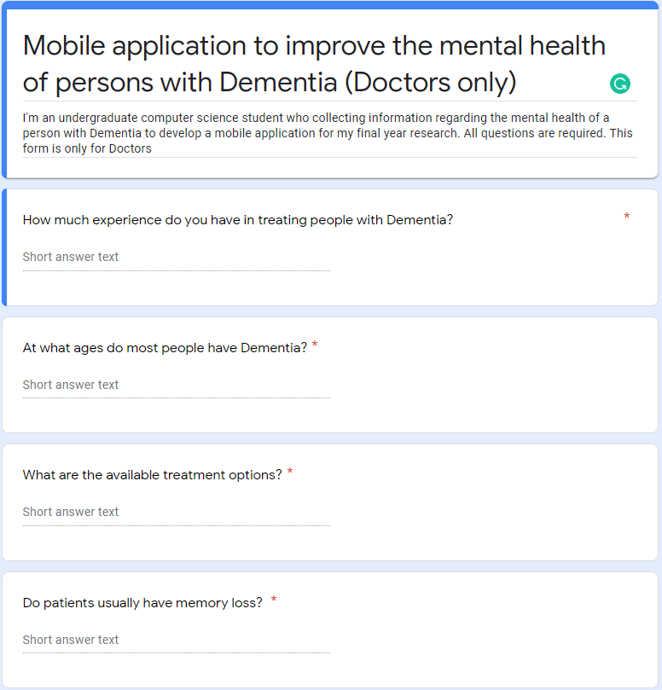

Figure 1 - Doctors' questionnaire form screenshot 1

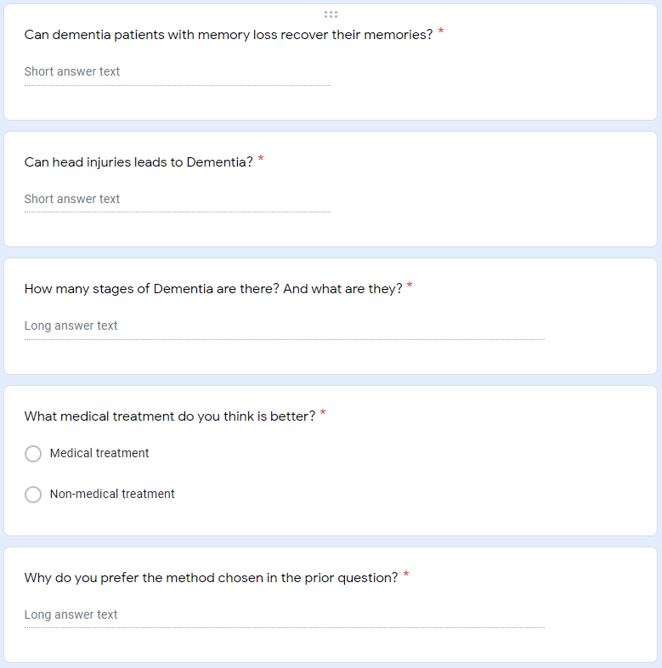

Figure 2 - Doctors' questionnaire form screenshot 2

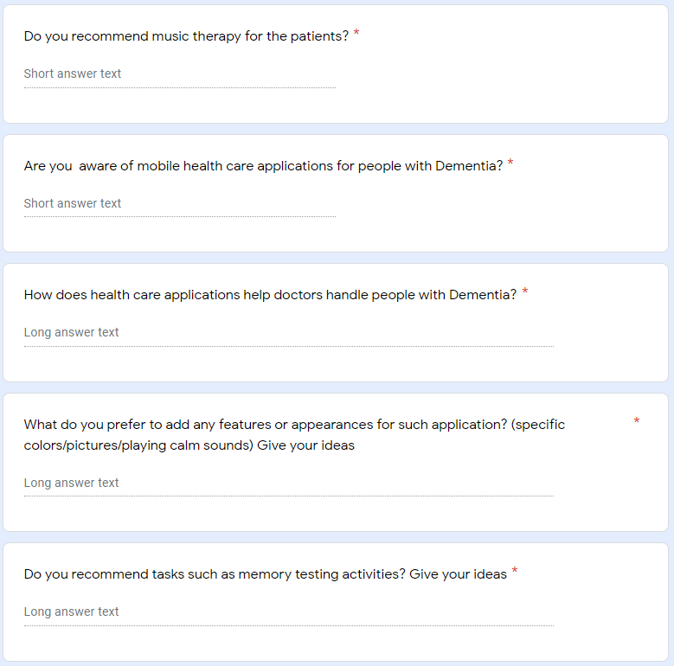

Figure 3 - Doctors' questionnaire form screenshot 3

Since the researcher received less responses in given period, the researcher took ideas from the responses to develop the application. Further the researcher conducted another feedback collection from sample populations who are care takers and family members of persons of Dementia selected from whole population. (Figure 1, Figure 2 and Figure 3) are the doctor’s questionnaire snapshots which given to all doctors. A survey of selected questionnaire was passed on to 40 people to gather the data. The researcher used Google forms to collect data. Then the gathered data was analysed using IBM SPSS Statics software.

The researcher’s first survey was to find the age limits of the among individuals. Majority of individuals are above 75 years old. Then the individuals are between 60 – 70 years old. The researcher has concluded that most people with Dementia are from elder generation. Following (Figure 4 – Pie chart of survey Question one) pie chart google survey respondents will explain the percentage of ages.

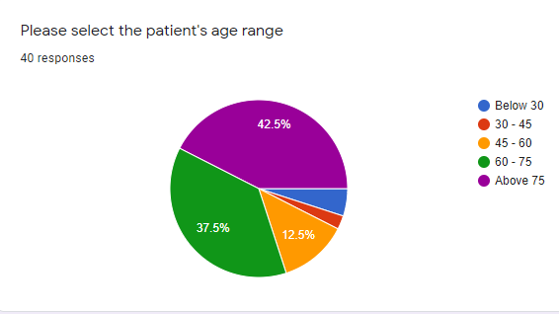

Figure 4 - Pie chart of survey Question one

Following (Table 1 – Frequency table for the survey Question one) stats taken from the IBM SPSS number of responds for each age given by the individuals

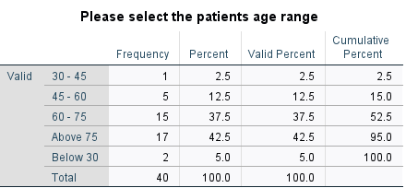

Table 1 - Frequency table for the survey Question one

The researcher’s next question was to find out how the respondent’s relationship to the persons with Dementia. Most of the respondents were the family members of the persons with Dementia. Following (Figure 5 – Pie chart of survey Question two) is the pie chart of the responds for the relation to the person with Dementia and (Table 2 – Frequency table for the survey Question two) shows the frequency table which is generated form the IBM SPSS for the question

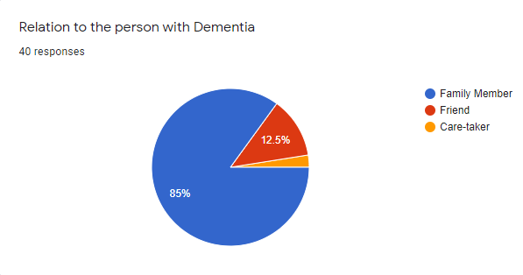

Figure 5 - Pie chart of survey Question two

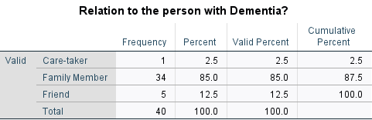

Table 2 - Frequency table for the survey Question two

Next the survey was focused on how long patient has been affected by the Dementia. Among the 40 individuals nearly 50% are more than 5 years. (Figure 6 – Pie chart of survey Question three) is the pie chart which represents the period since the patient affected by the disease and (Table 3 – Frequency table for the survey Question three) is the frequency data which is generated from the IBM SPSS statistics.

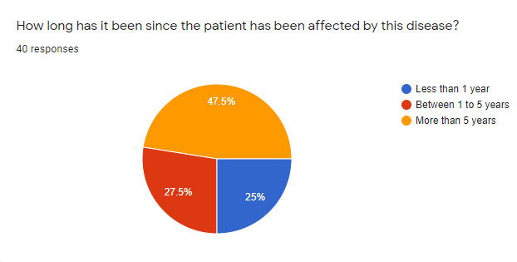

Figure 6 - Pie chart of survey Question three

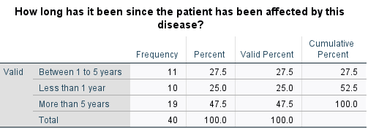

Table 3 - Frequency table for the survey Question three

Next survey was focused about the symptoms showed by the patient. More than 70% of individuals has short term memory losses and equal percentage of 57.5% individual’s loss of ability to do daily tasks and personality and behaviour changes. (Figure 7 – Bar chart of survey Question four) explains the bar graph of symptoms which displayed by the persons with Dementia. (Table 4 – Frequency table for the survey Question four) explains the statistics which taken from the IBM SPSS frequencies.

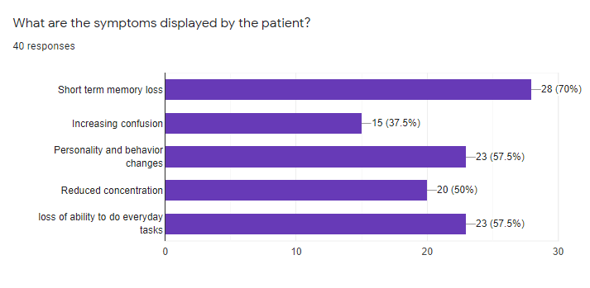

Figure 7 - Bar chart of survey Question four

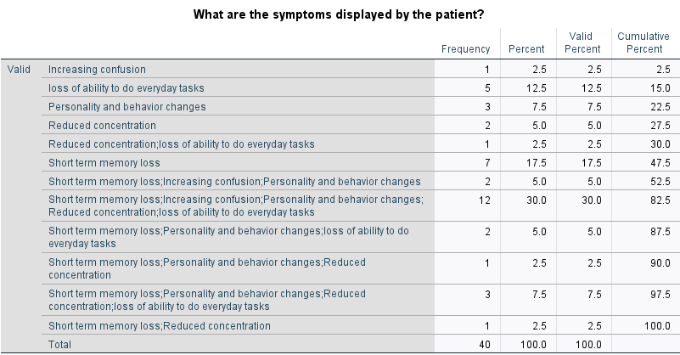

Table 4 - Frequency table for the survey Question four

Among the 40 individuals more than 60% of people have no prior experience with a person with Dementia. More than 30% have prior experience with the persons with Dementia. (Figure 8 – Pie chart of survey Question five) show the pie chart where each individual has prior experience with persons with Dementia. (Table 5 – Frequency table for the survey Question five) shows the statistical frequencies from the IBM SPSS.

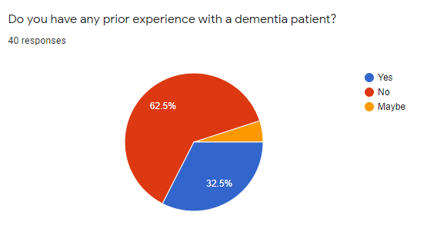

Figure 8 - Pie chart of survey Question five

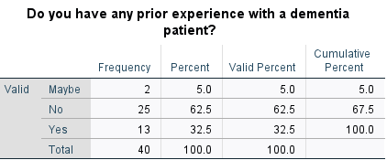

Table 5 - Frequency table for the survey Question five

Next survey was focused on that individuals have mobile phones. Almost everyone has mobile phones on their own percentage of people who are having mobile phone is 97.5%. (Figure 9 – Pie hart of survey Question six) shows percentage of pie chart from the google survey and (Table 6 – Frequency table for the survey Question six) is the frequencies from the IBM statistical.

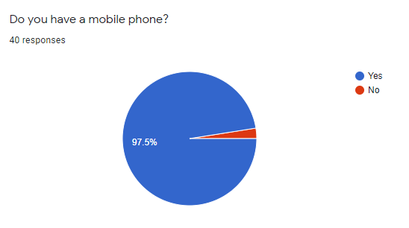

Figure 9 - Pie chart of survey Question six

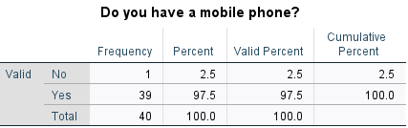

Table 6 - Frequency table for the survey Question six

The researcher’s next survey about individuals do aware of any mobile application to assist in improvement of the mental health of a person with Dementia. More than 60% of individuals does not aware of health care applications available in application store. (Figure 10 – Pie chart of survey Question seven) is the pie chart where the awareness of the increasing the mental health of a Dementia patients by using mobile application. (Table 7 – Frequency table for the survey Question seven) is displaying the frequencies generated from the IBM SPSS.

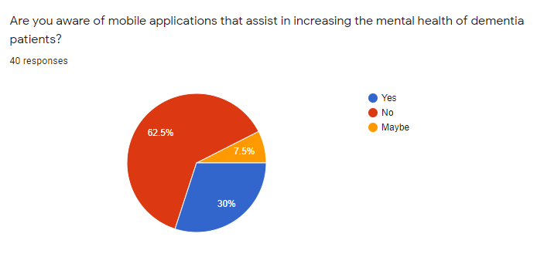

Figure 10 - Pie chart of survey Question seven

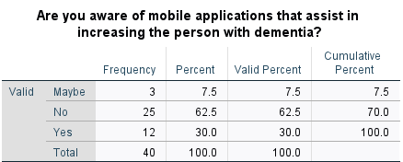

Table 7 - Frequency table for the survey Question seven

Next survey about what recommended activities by doctors for persons with Dementia. More than 60% recommending music therapies and brain exercises for the people with Dementia. Exactly 60% is recommending brain exercise for the patients. Rest of 42% is recommending let the patient feel that they are not alone. (Figure 11 – Bar chart of survey Question eight) depicts the bar chart from google questionnaire given below. (Table 8 – Frequency table for the survey Question eight) shows the statistical data from IBM SPSS

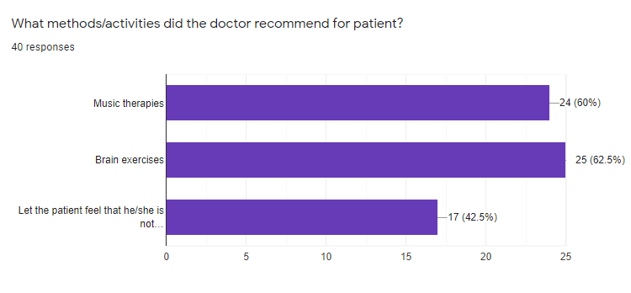

Figure 11 - Bar chart of survey Question eight

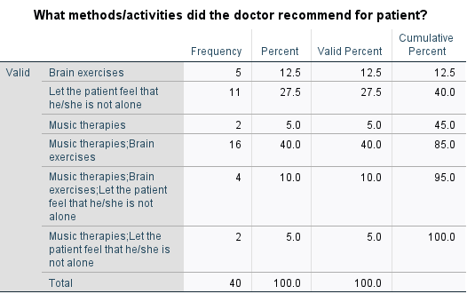

Table 8 - Frequency table for the survey Question eight

Next survey about what users expecting recommended features from a mobile application to assist a person with Dementia. 65% individual’s choice was brain exercise games from the application. More than 60% decided to have music therapy in the application. 57% of responds are for the memory recall activity. Following (Figure 12 – Bar chart of survey Question nine) is showing the bar chart for the question nine given below. (Table 9 – Frequency table for the survey Question nine) is showing the statistical frequencies took from the IBM SPSS.

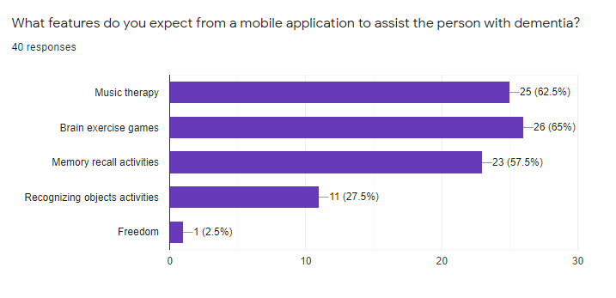

Figure 12 - Bar chart of survey Question nine

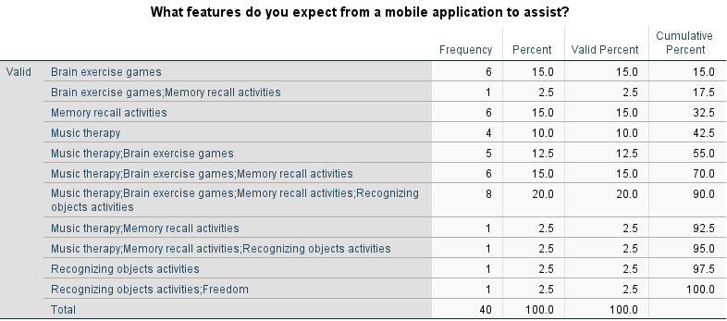

Table 9 - Frequency table for the survey Question nine

# Chapter Three – Methodology

The methodology chapter of this thesis discusses the methods used to tackle the case, and the event methodology that was used. The segment further discusses how data and information is gathered and analysed. The instruments used to design the artefact correctly will be included in this segment.

Selecting which approach to be ideal for the chosen project to be built is crucial, since it will affect the project's overall results. Despite the fact that the application is cantered in a very straightforward relation to its customers, flexibility, and most importantly, specializing in the project's requirements, the use of Agile Scrum technique has now been finalized, this system will be beneficial to the project (Kataria, Shrivas, Shukla and Hemlata, 2017). The technique enables a requirement analysis at the outset of each sprint, allowing for small changes while ensuring stability and making appropriate modifications during the testing process. The agile scrum technique is described by the characteristics mentioned below.

Agile methodology characteristics

* Quality is maintained - at the end of and production sprint, it is checked to see if anything is up to standard.
* Flexibility - There will be no restrictions on artefact execution, and device changes will be made if required.
* Time limit - Since the proposal appears to be large, methodological sprints guarantee that it is completed within a set amount of time.
* High user engagement - although production is often reviewed after and sprint, real-world feedback is frequently incorporated into the implementation.

(Figure 13 – Agile Methodology Phase) showing the Agile model phases and figure describe the phases are given below.

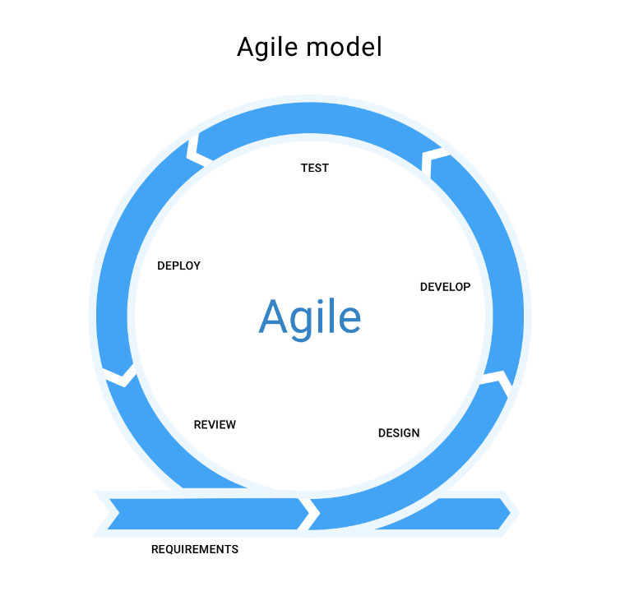

Figure 13 - Agile Methodology Phases

## 3.1 – Planning and Analysis

The foundation of every good project is system planning. Each system requires a method for implementation and development. The look process was followed by a thorough examination of the data technology advances that were needed. The artefact's definition was snatched after a thorough examination of numerous documents and publications written in the manner of web articles, books, and reports.

After that, it was checked to see if the chosen subject was feasible. The underlying issue that was discovered was the need to organize the topic. Since digitalization is advancing at a rapid pace, it was important to reintroduce an upgrade to the system software. As a result, it was necessary to examine a variety of themes, which led to the discovery of many areas. The bulk of the study topics would be much more powerful and accomplished within the time limit, while the others would not face almost as many challenges.

The development of the project proposal, which was followed by this precise interpretation and a brief description of the artefact, clearly outlined the system's aims and priorities, as well as a feasible approach for completing the work.

In order to meet the needs of the system's intended audience, thorough implementation analysis and collection of all significant criteria, apart from project design and development, was required in order for the project proposal to be accepted. As a result, the tools that would best complement the project's personality must be chosen, and the decision was made to use the Android Studio IDE.

A major aspect to be faced was effective time control in the project planning process. The application was designed using the Agile scrum technique, as discussed in the analysis. As a result, time allocation was integrated into each level of production. Planning should be done with the urgency of each job in mind, and time scheduling should be precise, following the methodology, and completed within seven to eight months to finish the project successfully and efficiently. Initially, the Work Breakdown Structure was static in order to simplify the most important functions. Gantt chart shows (Figure 14 – Gantt chart), all information about the projects completed and the time allotted to them the job is broken down into little pieces to make it much smoother and quicker.

Every necessary phase and thus the significant decisions in relation to the features to be followed by the structure, tools and technology, methodology and thus the project model, scenario, and the goals and objectives to be accomplished were crucially paid attention to finalize accordingly with the assistance of research works conducted at the beginning stage of the project. Several changes to the time schedule were made during this study phase, including the addition of functions such as the implementation of an AI chatbot, and the distribution of time periods changed accordingly within the specified overall research time period.

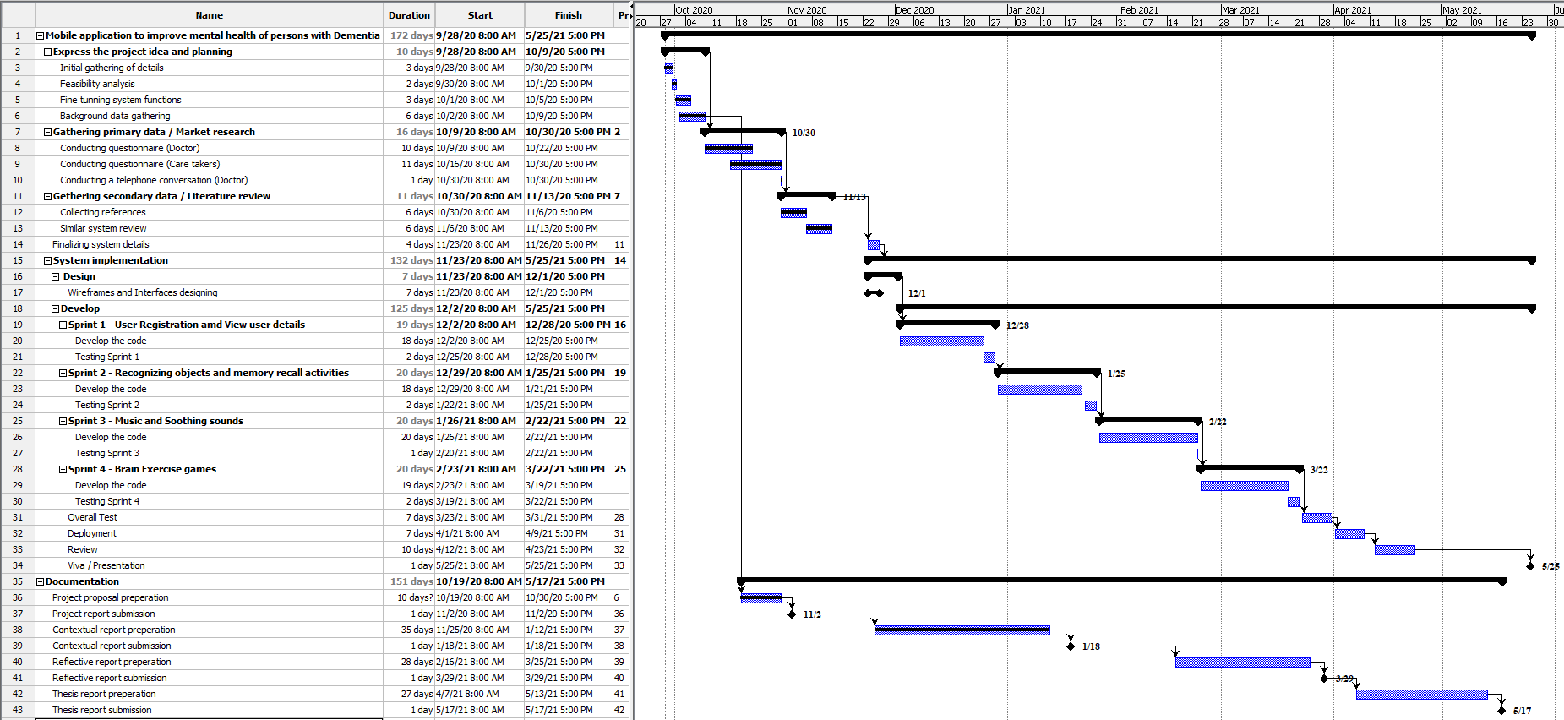

Figure 14 - Gannt chart

As mentioned in the above paragraph researcher lately decided to add an AI component to the proposed application. Sometimes Gantt charts not reliable to time plan management since if we add a new feature as a sprint development, we need to adjust time frame once again. Only solution is to finalize the final requirements before we start developing the system.Planning is the secret to any good system, and careful planning was essential to ensure that the new system was delivered on schedule. A work breakdown structure (WBS) (Figure 15 – Work Breakdown Structure) and Gantt map were developed to simplify and streamline the look process.

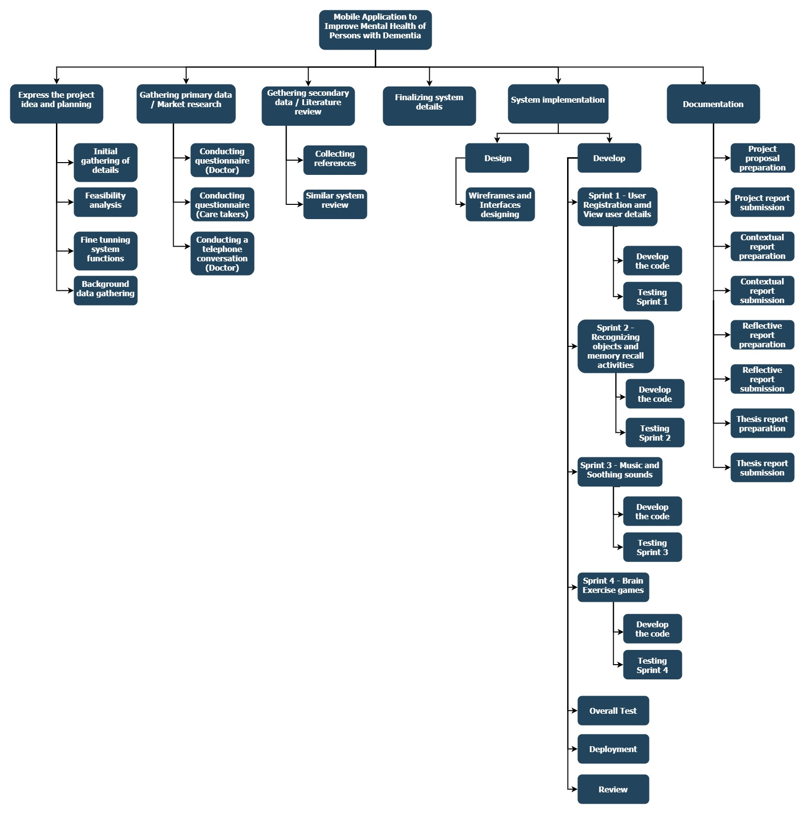

Figure 15 - Work Breakdown Structure

The WBS was used to break down the overall system's configuration into smaller functions. The overall framework was split into five major roles to develop the WBS for the proposed scheme.

* **Planning** - The task entailed conducting a feasibility analysis to better understand the new system's design and how it could be implemented. According to above work breakdown structure initial data gathering, feasibility analysis and background data gathering are the tasks included in the planning section. The researcher must properly fine tune with the functions of the proposed system before steps into next levels
* **Requirement** **Gathering** - The aim of the study was to achieve a greater understanding of the proposed system's context, and the final result was a literature review. According to the above work breakdown structure examples for this section is mainly primary data gathering where conducting market research where providing questionnaires to research relating parties in order to collect their ideas and experiences and secondary data gathering where collecting data and information from secondary sources such as journals, reports posted in Google Scholar database or IEEE Xplore database or any other websites. Further details explain under below next chapters.
* **Design** - The task entailed reviewing the specifications and deciding on a system design to go forward with. Diagrams of functional flow, use case, sequence, and data model were created during this project. According to the above work breakdown structure designing the wireframes and designing the user interfaces are the tasks which are done in design phase. Further details explain under next sub chapters.
* **Implementation** - During this project, implementation was done using sprints according to the Software Development Life Cycle model chosen. According to the work breakdown structure the researcher needs to divide the whole development parts into small parts which are called sprints. Each sprint represents a function which is related to the proposed system. After end of every sprint we need to test the sprint before we step into the next sprint.
* **Testing** - A research was performed to decide when and how the system could be tested, and the testing was carried out accordingly.

## 3.2 – Requirement gathering

Requirement gathering may be described as the process of learning about the desires and needs of the target audience through analysis. During the need and collection process, significant and contributing analysis was required to determine the subject's adequacy. A market survey was performed, and this project's research papers were used.

The two popular methods for combat operations were a literature analysis and an industry survey on emerging platforms. For the literature review, the IEEE Xplore database and the Google Scholar database were both useful and accurate resources. The framework has incorporated the most recommended and crucial features, taking into account the most recent years of publications within the last eight years and gathering data to maintain a qualitative up to date analysis area and to examine widely regarded knowledge and requirements needed by the application. The goals for this approach and, as a result, the additional changes that need to be made, can be checked in a later section.

The following keywords were discovered when searching for relevant information for the research:

* Dementia
* Counselling
* Application
* Alzheimer’s
* Relaxation methods
* Music
* Artificial Intelligence
* Machine Learning

Throughout this research, the most relevant papers and records were identified, and after each article had been gathered, it had been browsed to check its relation to the topic in order to ensure that the best evidence collected had been wont to rationalize the proposed artefact's occurrence.

## 3.3 – Design and Implementation

### 3.3.1 – Interface Design

Mobile application consists different interfaces which have designed by the developer. Why Facebook uses the blue colour theme? The researcher researched for colours which are suitable for application. Most of the sites recommended colour blue reason state that users grab their attention for colour blue. The researcher selected the blue colour as theme colour because of the reason is user easily get attention to the colour blue. Finally, the researcher decided to use blue and white colours combination. Then the researcher thought to use creative pictures for dashboard icons where user can easily remember the tile even though user cannot remember the name of the tile. For an example user can identify the Demibot interface by looking at the Demibot icon even though he cannot remember the name Demibot name. Each interface having their own tasks or it redirect to another interface for the user. The system ran smoothly because the interfaces were planned ahead of time. The interfaces were first established, and a strategy for developing them was devised. The system's key interfaces were defined as the ones mentioned below.

* Login Interface
* Registration Interface
* Dashboard Interface
* View profile Interface
* Recognizing colours activity
* Recall items activity
* AI chatbot
* To-do list Interface
* Reminder Interface
* Music Player

**Login Interface**

Two text fields were used to enter the account email and password in this interface. A button was added to allow the user to apply the information they had entered. Login function simply comparing user details in Firebase database. If user already registered or exist in the database user can successfully logged into the system. Another link was added to navigate to the user registration interface. When user logout from the system and login to the system once again user has to provide user email and user registered password and after that user has to tick a checkbox where provided in login interface. Once the option is put a tick even though the user closes the application the user doesn’t need to provide login credentials after application opens. This function is called shared preference where login information will be saved in the database once the user login to the system until the user logout from the application.

**Registration Interface**

This is the GUI that is used to enter user data into the system. There are six text fields which user needs to add Name, User name, Age, Phone, Email and password and user need to click the button register in order to register in the system. These input textboxes validated by the code segments. User has to provide reliable information in order to registered into the system and creating a new user account. Another link was added back to navigate user to the login interface. If the user new to the system after successful registration user directing to the main dashboard.

**Dashboard Interface**

This is the interface where user can access to all the functions and activities. Also, interface contains navigation bar which can also have access to the functions and activities. Dashboard interface contains Activities, Music, About, Demibot, To-do list and Reminders tiles where user can navigate to each feature what user wants to do.

**View Profile Interface**

Once the user navigates to the navigation bar, there is an option called view profile where user can view their user profile details and also the user can have ability to update their user data by clicking a button.

**Recognizing colours activity**

This is the interface where user can test their memory which can identify colours. Once the user starts the game user needs to spin the wheel to match the colour which is randomly provided by the system. User needs to complete the task in a given period of time. Game will be over if the user unable to complete the task within the time period.

**Recall Items Activity**

This is the interface where user can test their memory which can identify objects. Once the user starts the game randomly system show a letter in given circles and hide it in few seconds. User needs to remember the circles where the letters appeared and select the circle. The reason which is the Researcher used a letter for this activity instead of using a picture or another item which user can remember easily. This is because the if the researcher used a picture or any other item user can easily grab it into his memory. In here the researcher try to implement an activity which is recall the user memory. If the researcher used pictures or images or any other attractive things to this activity, we cannot gain successful results. This task in need to complete in a given period of time. Once you pass the levels the game will be harder by reducing the time allocating to the user. Game will be over if the user unable to complete the task with in the time period.

**AI chatbot Interface**

AI chatbot is the research component which is developed to this system. This is the interface where the users get interacted with the system. This interface is a chat screen where user can build a conversation between user and the chatbot. This system was developed from Python language. Chatbot is running outside from the where PyCharm is used to developed the chatbot and it was integrated to the system application.

**To-do list Interface**

This interface helps users to save their tasks or activities in this section. After completion of the task or activity user can delete from the list. In here user can save, update or delete their to-do tasks. All the to-do tasks save under the unique registration id where was given by the database just after the registration. User can add tasks once click in add task button and user can input a heading and description. Once the user inserts a to-do task user can update it by clicking the update button the relevant task. User can delete the task once it completes user can click on complete button, it will automatically disappear from the to-do tasks list

**Reminder Interface**

This interface helps user to save their reminders such as take medicine on time reminders. After completion of the reminder automatically deleting from the list. In order to add a reminder user needs to click on plus icon after that user directing to the interface where user to enter the information about the reminders. User can give a voice command to save the reminder by clicking on microphone. After that by setting time and date user can complete the reminder by clicking on done icon. Finally, soon the reminder save in database and notification will appear on notification panel which user can’t clear from the notification panel. Until the reminder completing or the reminder deleted by the user it will appear on notification panel. User can delete or update the reminder by long pressing on the reminder.

**Music Interface**

This interface provides user to play soothing music which is provided by the system application. The researcher searched suitable playlist where user can listen. Then the researcher found suitable playlist where all the songs slow and low beat songs which user can listen and user can calm down his mind.

**About**

Additionally, user can able to know about further more about Dementia. The researcher decided to put all the research information inside the application for additional knowledge for the user. By reading this information care-takers can get an idea about the Dementia.

### 3.3.2 – Function design

The preparation of the appliance plays an important role in ensuring the system's successful execution. The application's intent would be conditional on the creation of a successful design. The project's designing stage reflects all UML schema that is heavily based on the appliance's deciding requirement. These UML diagrams, like usage case diagrams, are also discussed below in order to fully comprehend the appliance and how it works, thus assisting in the system's essential implementation.

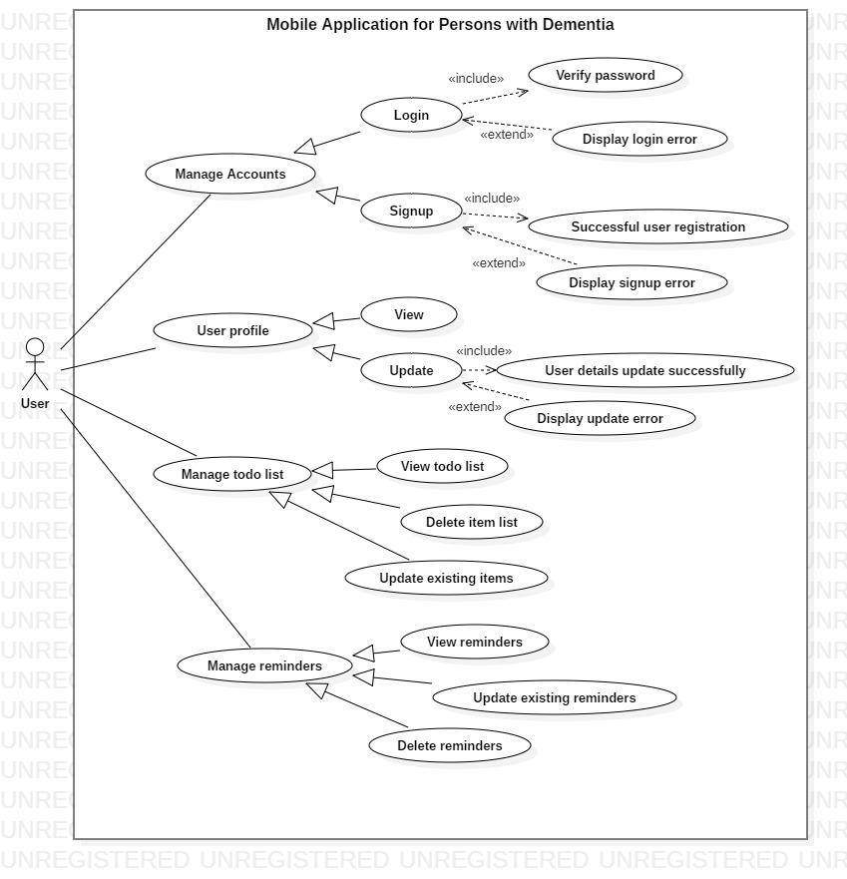

Figure 16 - Use Case Diagram

By looking for the requirements demanded from the consumer's perspective, use case diagrams to help ensure that the right structure is developed. It simplifies things by breaking down the program and focusing solely on its core functionality (Elenburg). As shown in the above figure (Figure 16 – Use Case Diagram), the system has only one role to participate; only the user itself. If the user new to the system, user needs to provide their valid information to the system in order to register in the system and create an account. If the user already registered user they can provide their credential to the login interface and logged into the system. Once the user logged into the system, they can access to all the features available in the system as well as user can have ability to view their user profile and they change their personal data and update their personal details under the profile section. In above use case diagram user can able to manage their to-do list by adding tasks which they want to complete in future also system provided user options such as delete, update as well view the list. Proposed system provides user to save their reminders as well. User can add their reminders such as their medicine doze take or other reminders. User can also delete, update or view reminders. All of the above-mentioned functions user can access after the user login to the system through signup to an account.

It is necessary to create a specification if the suggested framework is to be applied. This project, which was written in the Java programming language, was developed using the Android Studio IDE. According to the report, the health-care application was found to be more user-friendly, as well as appropriate and trustworthy to use.

The proposed system database using Firebase database which is easy to handle active login accounts. At the earlier stages of the research, the researcher needed an idea which database Firebase or SQLITE is suitable for the proposed system. So, the researcher search what are pros and cons in both databases. After with the help of the supervisor, the researcher decided to choose Firebase database. It is easy to use Firebase because Google provides the facility of Firebase Authentication for every registration. A firebase database can allow cloud data backup and login, and the cloud base database will be accessed from anywhere and on any computer using firebase authentication. But later the researcher used SQLITE for storing reminders inside device memory.

The research component of the proposed system developed using Python language to develop the backend of the Demibot in application. The researcher developed the Demibot separately and the researcher used PyCharm IDE with Anaconda plugin to develop the chatbot. To develop this chatbot the researcher used Natural Language Toolkit NLTK which is a Python-based collection of libraries and programs for symbolic and statistical natural language processing (NLP) for the English language. Also, the researcher used TensorFlow free and open source library to develop the chatbot which is helpful for ML. It can be used for a variety of functions, but it focuses on deep neural network training and inference. The researcher user Keras API for deep learning in which is written in Python. Keras is running on top of the TensorFlow platform. It was created with the goal of allowing for fast experimentation. It's critical to be able to go from concept to outcome as quickly as possible while doing analysis.

After development of the chatbot the next step is to give a training to the chatbot. For that the researcher create a dataset and modified accordingly which is suitable for the application. For this the researcher used JSON arrays called intents. The JSON file is being used to generate a set of messages that the user is likely to type and map them to a set of suitable responses. In these intents the researcher modified the tags which is describe the patterns and responses in one word, patterns are the all the possible questions user can ask from the chatbot which is related to the tag, responses are the replies which are given by the chatbot.

After the training integration has to be done. Before that we need to check the connection with the user and the chatbot. For that we need to use the application called Postman.

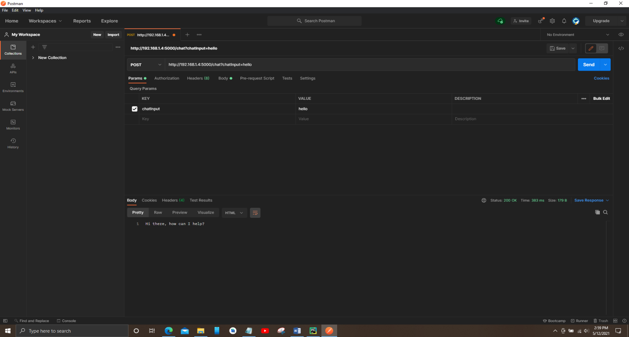

Figure 17 - Connection establishment with chatbot in Postman

Above figure (Figure 17 - Connection establishment with chatbot in Postman) shows how the connection is going to establish with the chatbot. For the connection method need to take either ‘GET’ or ‘POST’ method. After that need to provide the following URL link <http://192.168.1.4:5000/chat?chatInput> where the researcher has to provide the PC IP address with :5000 also provide the app route name ‘chat’ and finally need to provide the key ‘chatInput’ then need to input a value and send.

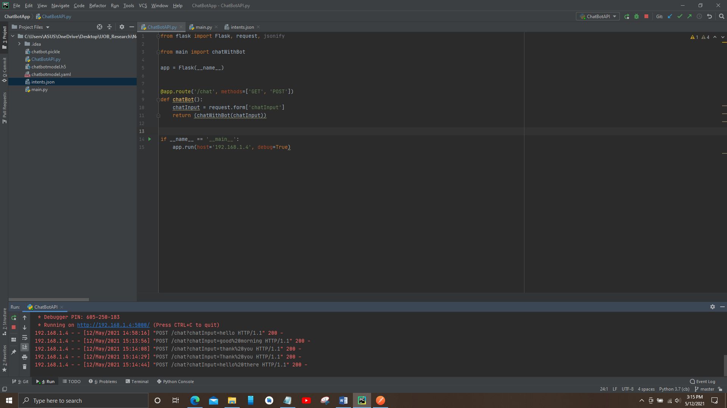

Figure 18 - Connection requests received by Postman from POST method

Above figure (Figure 18 - Connection requests received by Postman from POST method) showing the successful testing connection requests received from the Postman application. After the testing part is done, the researcher needs to call the URL link inside the Java chatbot class assign to a String URL and also set the request String request method as POST and the URL.

The methods and technology that were chosen to create the device are described below;

* Microsoft Word: Throughout the project, this was used to create all documentation.
* Android Studio IDE
* PyCharm Community Edition with Anaconda plugin
* Anaconda 3 Navigator
* Postman
* Java programming Language
* Python 3.9
* SQLITE: was used to store all the reminders in device memory
* Firebase Authentication: was used to build user profiles as well as their authentication functions.
* Firebase Realtime database: was used to keep track of user information and a to-do list
* Draw.io
* Star UML
* Project Libre

At the end of each sprint, adequate testing was carried out on each module, as well as the integration of all other components, as well as extensive testing and assessment to ensure the system's precision and functionality.

# Chapter Four – Results and Discussion

This section of the study explains the overall machine functionalities using references and diagrams to aid comprehension. Furthermore, it explicitly shows the efficiency, precision, strength and weakness, and operating challenges encountered during the implementation process, as well as how these obstacles were theoretically fixed to accomplish the goal and goals set out at the outset, as well as the customer criteria, to create a successful framework that meets the requirements

This section's main goal was to provide a quick rundown of all of the project's features and functionality., as well as to portray the importance of each one. Mainly for understanding the “Dementia Care” health care application system.

Mainly, the “Dementia Care” interfaces were design using fragments in order to reduce the weight of the application and also it minimizes the size of the application. As a result, each software application was created in a way that was both interesting and interactive in order to increase the rate of versatility and productivity.

## 4.1 – Functions

Once the application is installed on the device after successful installation user needs to enter LOGIN details in the login screen to use the features of the application further. When the log in button is pressed after the initialization process is complete, it will begin to authenticate the information entered in order to verify the user. Since the code is built on Firebase, it requires Firebase authentication. The user will be routed to the main page as soon as they log in. The customer is then granted permission to use all of the application's features and functions.

If the user hasn't already done so, REGISTER by filling out the required information and logging in with an email address and other user required information provided in Register interface. When you click the sign-up button on the login tab, the sign-up page will appear, and you can register by clicking the CREATE ACCOUNT option. The new user will be authenticated as the Firebase verification is being processed, and the information will be saved of the cloud store in the Firebase database as a result of the active registration of the new user. After successful registration Firebase Realtime database provide a unique id to each user.

Once the successful registered user login to the system while entering the user login details in login interface and click sign in button. Before sign in to the system user needs to check the tick in REMEMBER ME because in here the researcher used the shared preference method to remember the user. In shared preference it saves the login session once the user login to the system. Once the user login to the system, if the application closes user does not need to enter user login details once again in login interface in order to login to the system application. Login session is saved in Firebase authentication until the user logout from the system.

After entering to the system user directly entering to the dashboard, dashboard displays several interfaces where user can access to those interfaces. The user can able to do activities such as MEMORY RECALL ACTIVITY and RECOGNIZE OBJECTS ACTIVITY, first in memory recall activity there are three levels user has to complete from level 1 to level 3 increased easy to hard. Also, inside each levels number of circles increase. User needs to click on START NEW GAME in order to start the game. Once the user starts the level one by clicking start new game. Number zero will display inside one of the circles and disappear within seconds. User needs to identify the circle where the zero was displayed in which circle. If the user was able to identify the correct circle where it was displayed the game will getting little bit harder and it will be displaying the number of zeros will be increases and user needs to select all the circles where zeros were appeared. After completing the level system will displaying a successful completion message with a victory animation. The researcher wants to show that the user is a winner, by looking at the winning message user needs feels that user can go through with his mental illness and gradually user builds his/her self-confidence. Next activity is RECOGNIZE OBJECTS ACTIVITY, when we talk about objects, we can use anything including colours, same methods used for memory recall activity. But in this activity user needs to identify the colours and choose the correct colour in a given period of time.

User can have ability to listen to the music which system provided playlist. The researcher has developed a music player inside the application. User can have a chance to use to music player with basic functions such as paly/pause, next/previous buttons, volume control and seek bar control. Playlist includes slow low beat songs which are suitable for persons of Dementia.

User specially for care takers or family members of persons with Dementia can have an idea about Dementia or they can have further knowledge about Dementia by reading the information in ABOUT. The researcher decided to put all the information which were gathered during the literature review. The researcher hopes that the information is valuable to the user who are reading the facts inside the about.

DEMIBOT is the chatbot where user can have a chat with the chatbot to get information. This is the important function where this is the research component of this project. Demibot design using Python language separately design and integrated to the system.

System provides users to save their To-Do list by clicking ADD TASK. User needs to enter task topic and also task description in add task interface. After clicking on SUBMIT button popup will appear whether that user needs to add another task or not. If the user wants to add another task user needs to select yes after that system will re-direct to the task adding interface. User can update the existing task by clicking pencil icon showing in the task. Also, user can delete or remove the task by clicking on green colour tick icon by marking the task as completing. After completing the task, task will delete from the list and as well as from the database. All the to-do list tasks saving under the unique id which was provided by the user registration under that user id system will provides another unique task id.

Finally, system provides Reminder function where users can store their reminders. User needs to click on plus icon below in the Reminder interface. System will be directing to an interface where user can add Reminders. User can add reminders in two ways, either typing the message or user can enter a voice message in order to input the message. After entering the message user needs select the time and select the date. After selecting user needs to click done. Soon after done saving notification of the reminder will appear on the notification panel which cannot clear until the reminder is completing or deleting the reminder. User can also delete or update the notification by long clicking on the reminder and popup will appear whether to update it or delete the reminder.

Additionally, there is another feature where user can rate the application and give a feedback to the developer. By clicking on navigation there is option called RATE US, by clicking on rate us user can give a rate by click on stars and provide a feedback. By clicking on stars automatically shows rate is provided whether the rate is bad to best. Also, user can leave a comment down and click on submit button and it will save on Firebase Realtime database. User can also see their previous ratings before entering new rating.

## 4.2 – Accuracy and Reliability of the System

DEMENTIA CARE application’s accuracy and dependability are determined by deciding when it meets its goals and achieves its goal. After being evaluated, the application should yield the desired outcomes and perform as expected.

The program should be assessed in terms of its intent and whether or not this purpose is fulfilled, as well as whether or not the consumers are able to meet the goal of using it. DEMENTIA CARE is a health-care app, and it has to make sure that the whole app is built with the consumer in mind, so that they can benefit from it and get the most out of it. The accuracy of the program refers to the accuracy of the content it produces; for example, chatbot can react quickly to anything the user types.

The program would need to be tested further to see if it performs as intended. The program must be able to ensure a reasonable level of reliability. DEMENTIA CARE application total functionality is rated at 75%. The success rate is determined by voice input, which is used in conjunction with the Reminder feature.

## 4.3 – Conclusion

Following the development of each feature, the application would be tested. Additional sprint-by-sprint monitoring will be carried out. The researcher would monitor the overall functionality of the program using a manual testing application. Once the program has been completed, it is retested to see if it is still functional and free of glitches and errors.

As certainly discussed in the above section, DEMENTIA CARE is a health care application with multiple features and functions for the user to maintain their memory and recover up to some extend and for the care-takers application will help how to deal with a person with a person with Dementia. The researcher hopes that the DEMENTIA CARE application will help for the lifestyle of the user.

The way the system's functions and functionality are expressed has a big impact on the system's goals and priorities. Each of them has been created after careful consideration of how all of this would better serve the framework's productive operation, as well as the users who use it.

The system's features are extremely adaptable and user-friendly, with the aim of making it as easy as possible for someone with little to no technical experience to link to it.

# Chapter Five – Testing and Evaluation

The focus of this part of the thesis is on machine evaluation as queries. The material would emphasize device checking and ensure that the system runs smoothly for all users.

This segment will demonstrate the system's training as well as feedback from users. While testing the software was the last step in the SDLC, it was a significant accomplishment that showed the software's success or failure after all of the effort and dedication. And perhaps the system's usefulness is shown by ensuring that it is configured in compliance with the requirements. The finalized facets of the project would be tested by unit testing at the outset of each sprint, followed by integration testing before the device components are complete, and then final acceptance testing by the intended group during the final sprint.

## 5.1 – Evaluation

Along with the multiple-choice questionnaire, each person was given an answer questionnaire (Appendix N) to complete in order to obtain their feedback.

This is also another part of the implementation phase, and at the completion of each sprint, the system will be evaluated. This technique guarantees that all of the necessary specifications are fulfilled, as well as that the system is free of errors. Since the way of evaluating whether or not a project is a success is by assessment. As a result, the draft application addresses consumer acceptance explicitly. It was necessary to do a business analysis of existing solutions, including their complexities and shortcomings, in order to determine the features that current systems do not offer and the features that the community needs in a creative approach.

### 5.1.1 – Functional Evaluation

For the program to be functional, all of the system's functions must work properly. The system's functions are assessed using the parameters described below.

* The user has the option of opening a new account.

The application requires the user to build a personal account, after which the user will log in using valid credentials.

* Application understands the user

Application provides the chatbot function where user can ask anything from the Demibot to clarify their doubts

* Application educate the user about Dementia

Application provides researched facts to get an idea about Dementia and gain knowledge to take care of their loved ones

* Provide Reminders and Tasks feature

Application provides users to save their Reminders and to-do lists inside application along itself. User get notification until they completing the task

### 5.1.2 – Performance Evaluation

The system's overall efficiency is also assessed. The user interface is enhanced by high-performance software. The system's performance was assessed using the following criteria.

* Responsiveness

All of the interfaces load in 1–1.5 seconds on average, which is a reasonable sensitive pace.

* Security

Only the user has access to the user's sensitive details. As a result, the information is well protected. To access the dashboard results, the user must first log into the device.

* Usability

The user can easily understand the flow of the program interfaces. The desired functionalities can be conveniently navigated by the user.

* Mobility

The device can be accessed from anywhere using a smartphone since it is a mobile application. To use the device, the user does not need to be in a certain area.

* Availability

Since the majority of the operations are offline, the device is accessible to the customer 24 hours a day, seven days a week

* Maintainability

Since the framework is designed module wise, adding a new feature to the application is easy.

### 5.1.3 – Test User Evaluation

The feedback gathered from consumers who have used the program is essential for a thorough assessment of the method. A google form was developed and circulated to a community of chosen 10 participants each 5 male participants and 5 female participants to obtain the test user assessment of the method.

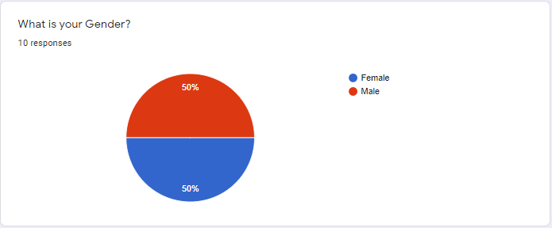

Figure 19 - Pie chart of user evaluation question one

Above figure (Figure 17 - Pie chart of user evaluation question one) show the gender response above mentioned participants. 50% from both parties are received responses from above 10 responders.

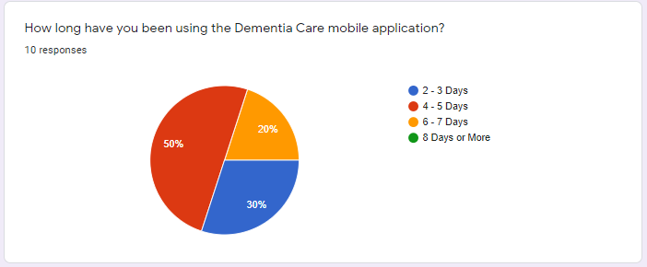

Figure 20 - Pie chart of user evaluation question two

Above figure (Figure 18 - Pie chart of user evaluation question two) elaborate Exactly 50% from the users have been used the Dementia Care application for 4 – 5 days since after system finalized. 20% users used the developed system 6 – 7 days and 30% users used the application 2 – 3 days out of the total participants.

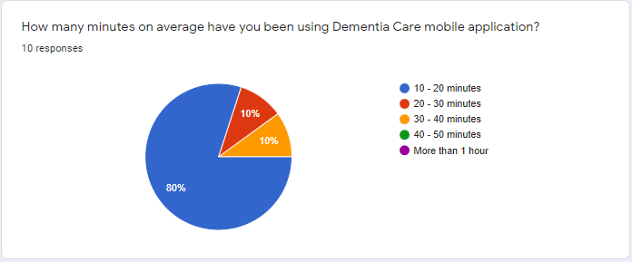

Figure 21 - Pie chart of user evaluation question three

Above figure (Figure 19 - Pie chart of user evaluation question three) shows Most of the users 80% respondents using 10 – 20 average minutes. 10% each using 20 – 30 minutes and 30 – 40 minutes.

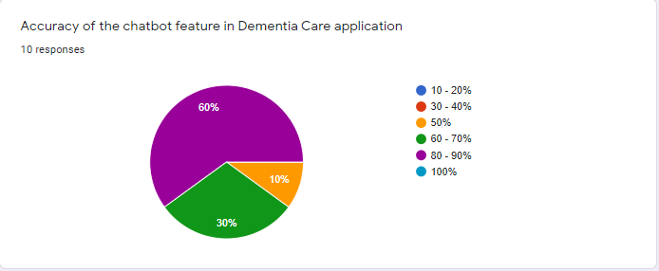

Figure 22 - Pie chart of user evaluation question four

When we discussed about the accuracy of the chatbot 6 responds 80 – 90% accuracy for the chatbot. 3 responds for 60 – 70% accuracy rate and 50% accuracy marked by 1 respond stating there was a problem occurred when searching a question but the bot responding a wrong answer as shown in the above figure (Figure 20 - Pie chart of user evaluation question four).

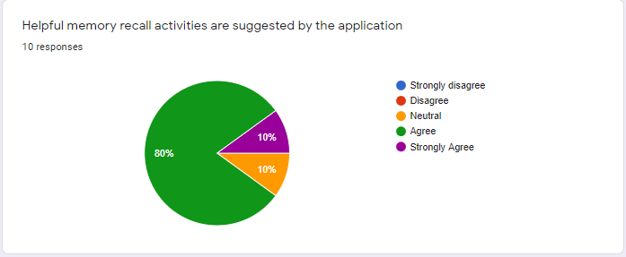

Figure 23 - Pie chart of user evaluation question five

Then researcher needed to have a feedback about the memory recall activity which have been implemented in the system. Above figure (Figure 21 - Pie chart of user evaluation question five) shows 80% of the total responds agree with memory recall activity is helpful for them. 10% from the total strongly agree with the memory recall feature which have been implement and rest of the 10% responded for the neutral.

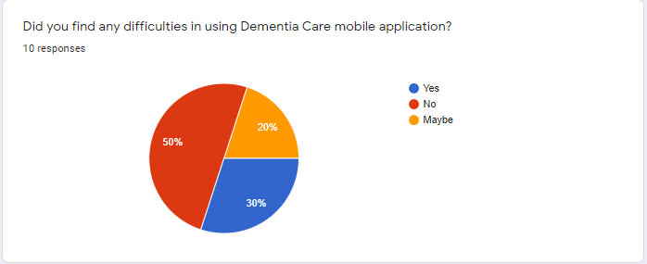

Figure 24 - Pie chart of user evaluation question six

As shown in the above figure (Figure 22 - Pie chart of user evaluation question six) discussed about how users find difficulties in using the Dementia Care application. 50% of the users didn’t found any difficulties. 30% of the users found difficulties and rest of the 20% users are neutral state.

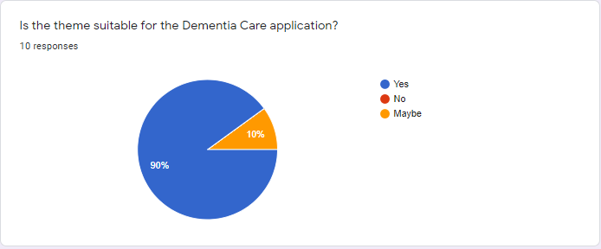

Figure 25 - Pie chart of user evaluation question seven

As shown in the above figure (Figure 23 - Pie chart of user evaluation question seven) discussed about the theme which have been used in the application. Almost everyone agrees and like the theme of the application. 90% users like the colour combination and the clip arts included inside the application. Rest of the 10% user respond as neutral.

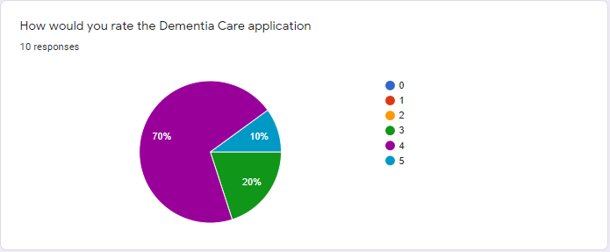

Figure 26 - Pie chart of user evaluation question eight

Finally, the researcher request all the respondents to rate the application. Majority users rate the application above 3 stars. Above figure (Figure 24 - Pie chart of user evaluation question eight) most of the users 70% given 4 stars to the application. Only one-person given 5 stars to the application. Rest 20% users given 3 stars to the application.

## 5.2 – Testing

### 5.2.1 – Test cases for Login and Registration

Table 10 - Test Case one User Registration

|  |  |  |  |  |  |
| --- | --- | --- | --- | --- | --- |
| **Test Case Number:** 1 | | | | | |
| **Name:** Registration with User Details | | | | | |
| **Precondition:** The user has navigated to the registration page | | | | | |
| **No.** | **Description** | **Inputs** | **Expected Result** | **Generated Result** | **Pass/Fail** |
| 1.1 | Insert valid details for registration | Name: Nimesh  Email: [nimeshmendis1997@gmail.com](mailto:nimeshmendis1997@gmail.com)  Age: 24  Password: nimesh@12  Contact number: 0774801447 | Successfully registered and directed to the Dashboard | Directed to the Dashboard and Display “Successfully Registered” | Pass |
| 1.2 | Insert the name with white space | Name: Nimesh Mendis  Email: [nimeshmendis1997@gmail.com](mailto:nimeshmendis1997@gmail.com)  Age: 24  Password: nimesh@12  Contact number: 0774801447 | Display invalid email message | Display “White spaces are not allowed” | Pass |
| 1.3 | Insert invalid email | Name: Nimesh Mendis  Email:  Age: 24  Password: nimesh@12  Contact number: 0774801447 | Display invalid email message | Display “Fields cannot be Empty”  And “Sign up fail” | Pass |
| 1.4 | Insert invalid password | Name: Nimesh Mendis  Email: [nimeshmendis1997@gmail.com](mailto:nimeshmendis1997@gmail.com)  Age: 24  Password: 12  Contact number: 0774801447 | Display invalid password message | Display “Invalid password” | Pass |
| 1.5 | Insert null values for the registration form | Null inputs | Display empty fields | Display “Fields cannot be Empty”  And “Sign up fail” | Pass |

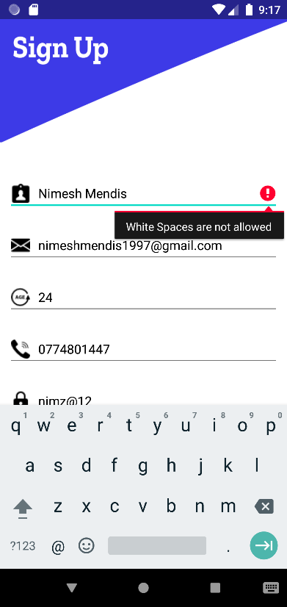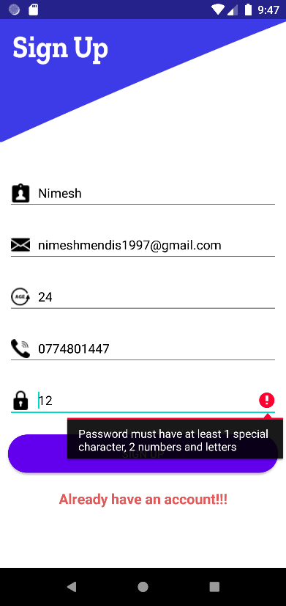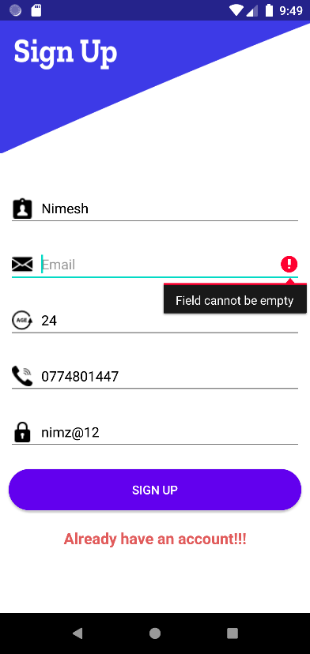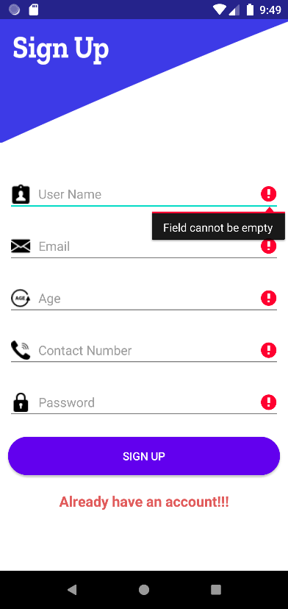

Figure 27 - User Registration Test Cases

Table 11 - Test Case two Login

|  |  |  |  |  |  |
| --- | --- | --- | --- | --- | --- |
| **Test Case Number:** 2 | | | | | |
| **Name:** Login with User Details | | | | | |
| **Precondition:** The user to have registered an account in the system | | | | | |
| **No.** | **Description** | **Inputs** | **Expected Result** | **Generated Result** | **Pass/Fail** |
| 2.1 | Insert valid login details | Email: [nimeshmendis1997@gmail.com](mailto:nimeshmendis1997@gmail.com)  Password: nimesh@12 | Successfully registered and directed to the Dashboard | Directed to the Login page and Display “Successfully Registered” | Pass |
| 2.2 | Insert invalid email | Email: nimesh@gmail.com  Password: nimesh@12 | Display invalid email message | Display “Sign in fail” | Pass |
| 2.3 | Insert invalid password | Email: [nimeshmendis1997@gmail.com](mailto:nimeshmendis1997@gmail.com)  Password: 12 | Display invalid email message | Display “Sign in Fail” | Pass |
| 2.4 | Insert null values for the Login form | Null inputs | Display empty fields | Display “Fields cannot be Empty” | Pass |

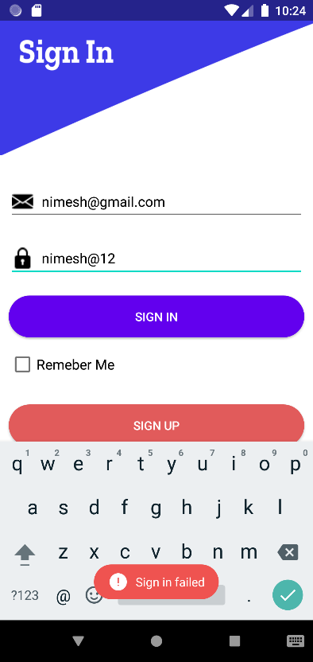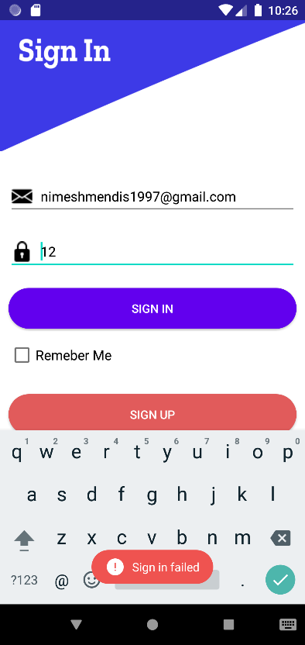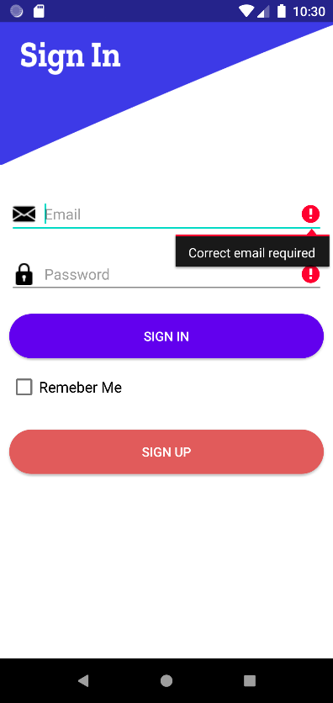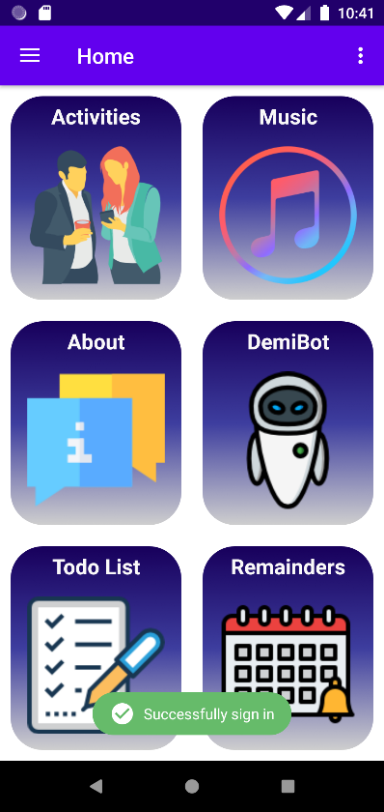

Figure 28 - User Login Test Cases

### 5.2.2 – Test cases for Activities

Table 12 - Test Case three Memory Recall activity

|  |  |  |  |  |  |
| --- | --- | --- | --- | --- | --- |
| **Test Case Number:** 3 | | | | | |
| **Name:** Memory recall Activity | | | | | |
| **Precondition:** The user to has to login to the system | | | | | |
| **No.** | **Description** | **Inputs** | **Expected Result** | **Generated Result** | **Pass/Fail** |
| 3.1 | Select wrong circle | Select a wrong circle where Letter ‘O’ didn’t appear | Display Game Over message | Display “You failed to complete the game” and need to start the game again | Pass |
| 3.2 | Select all the correct circles | Select all the circles where Letter ‘O’ appeared | Successfully completing the level | Display “Sign in fail” | Pass |

Figure 29 - Memory recall activity Test Cases

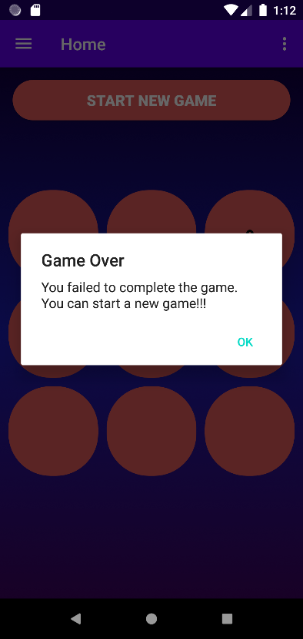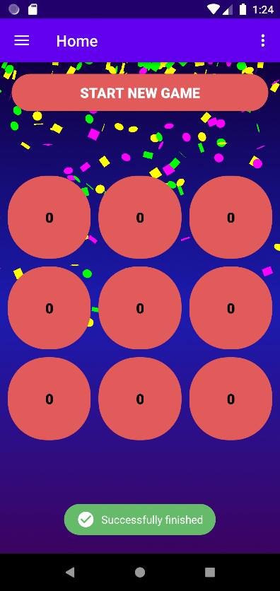

### 5.2.3 – Test Case Chatbot

Table 13 - Test Case four Chatbot

|  |  |  |  |  |  |
| --- | --- | --- | --- | --- | --- |
| **Test Case Number:** 4 | | | | | |
| **Name:** User chats with Demibot | | | | | |
| **Precondition:** The user to has to login to the system | | | | | |
| **No.** | **Description** | **Inputs** | **Expected Result** | **Generated Result** | **Pass/Fail** |
| 4.1 | Insert null input | Null input | Chatbot does not respond | Chatbot does not respond and Display “I didn’t get that try again” | Pass |
| 4.2 | Insert invalid input | Random letters “asdfg” | Chatbot does not respond | Chatbot does not respond and Display “That didn’t work” | Pass |
| 4.3 | Insert normal greeting | “How are you?” | Chatbot responds to the message | Chatbot respond to the relevant question “Hi there, how can I help?” | Pass |
| 4.4 | Insert a question related to Dementia | “what is dementia?” | Chatbot responds to the message | Chatbot does not respond correct answer to the question | Fail |
| 4.5 | Insert a question related to Dementia | “factors of dementia?” | Chatbot responds to the message | Chatbot respond to the relevant question | Pass |

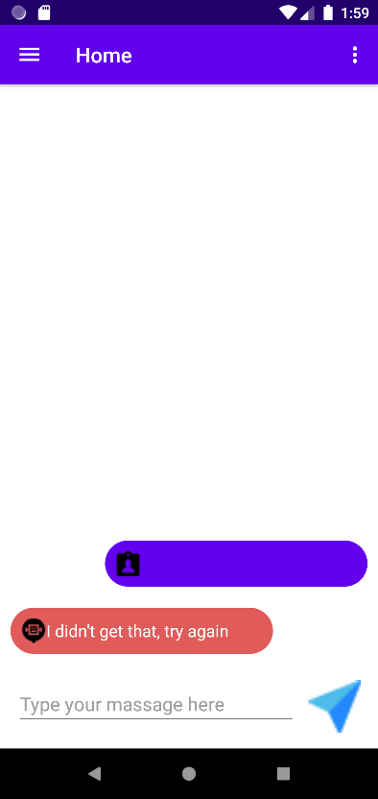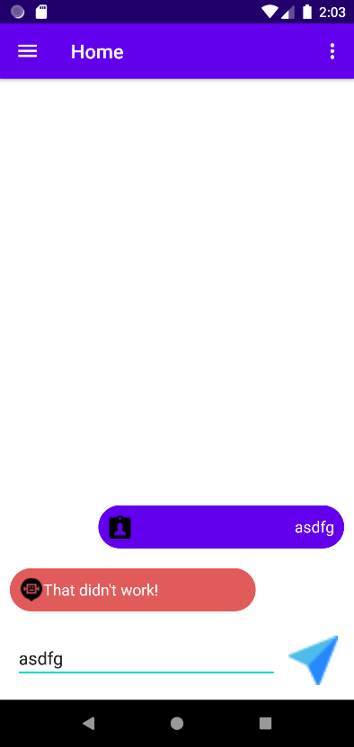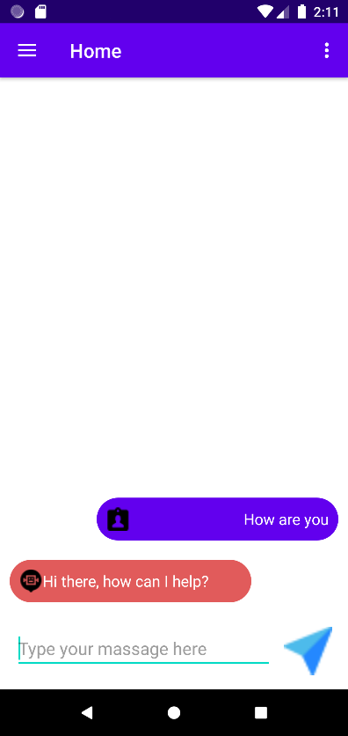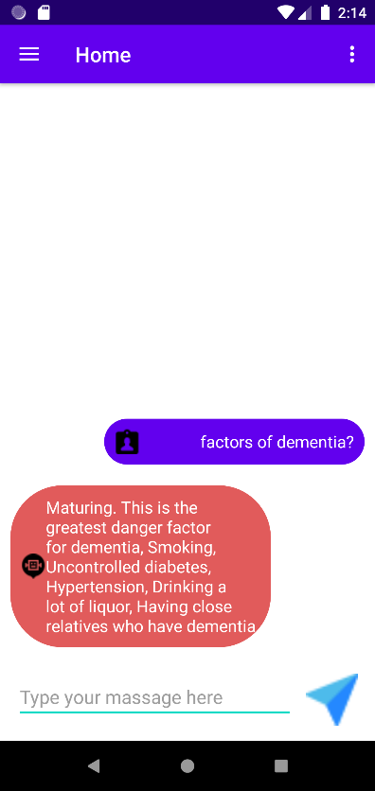

Figure 30 - Chatbot Test Cases

### 5.2.4 – Test case for To-do list

Table 14 - Test Case five Saving to-do tasks

|  |  |  |  |  |  |
| --- | --- | --- | --- | --- | --- |
| **Test Case Number:** 5 | | | | | |
| **Name:** User can able to save their to-do tasks | | | | | |
| **Precondition:** The user to has to login to the system | | | | | |
| **No.** | **Description** | **Inputs** | **Expected Result** | **Generated Result** | **Pass/Fail** |
| 5.1 | Insert a task | Topic: Test 1  Description: Test | Task added successfully to the to-do list | Display a successful toast message “Task added successfully” and task display on to-do list | Pass |
| 5.2 | Update the task | Topic: Test 2  Description: Test update | Task successfully updated on to-do list | Display a successful toast message “Task updated successfully” and task updated on to-do list | Pass |
| 5.3 | Delete the task | Delete Test 2 | Task successfully deleted on to-do list | Display a successful toast message “Task deleted successfully” and task will remove from to-do list | Pass |

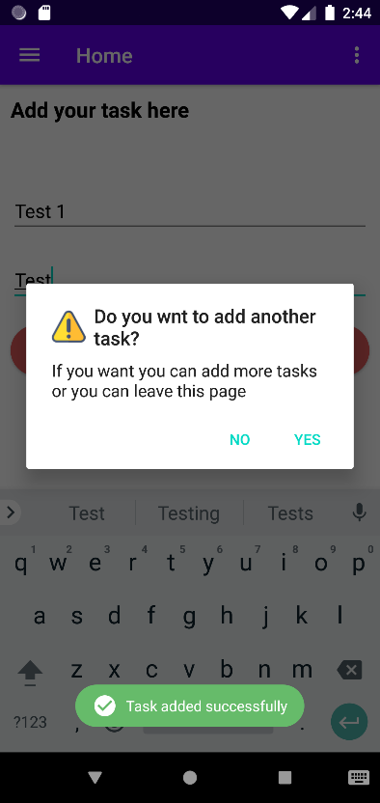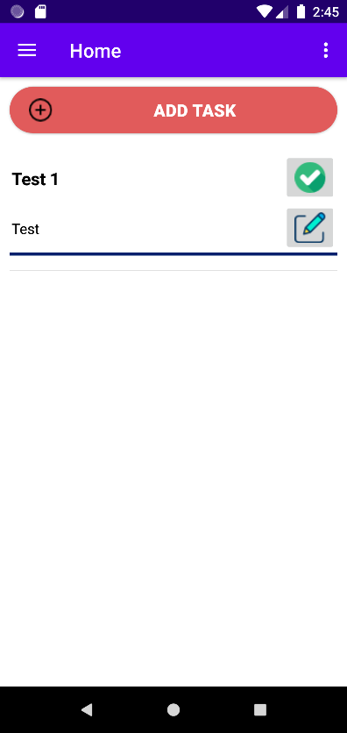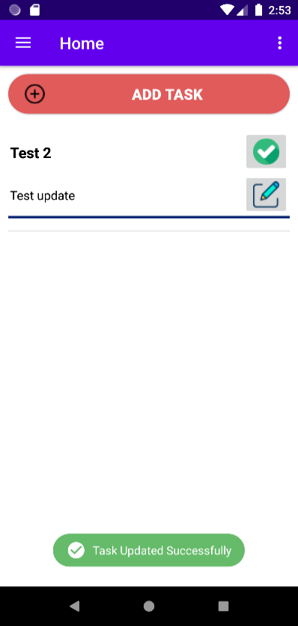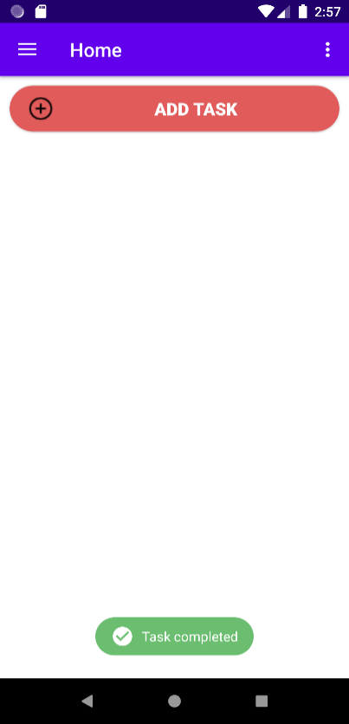

Figure 31 - to-do task Test Cases

### 5.2.6 – Test case for Reminders

Table 15 - Test Case six Saving Reminders

|  |  |  |  |  |  |
| --- | --- | --- | --- | --- | --- |
| **Test Case Number:** 6 | | | | | |
| **Name:** User can able to save reminders | | | | | |
| **Precondition:** The user to has to login to the system | | | | | |
| **No.** | **Description** | **Inputs** | **Expected Result** | **Generated Result** | **Pass/Fail** |
| 6.1 | Insert a reminder | Topic: Test 1  Time: Any random time  Date: Any random time | Reminder added successfully to the reminder list | New reminder will appear on the reminder list and also reminder notification will appear on notification panel | Pass |
| 6.2 | Update the reminder | Topic: Test 2  Time: Any random time  Date: Any random time | Reminder successfully updated on reminder list | Updated reminder will appear on the reminder list and display a successful toast message “Table my Events updated successfully” | Pass |
| 6.3 | Delete the reminder | Delete Test 2 | Reminder successfully deleted on reminder list | Display a successful toast message “Reminder deleted successfully” and reminder will remove from reminder list | Pass |

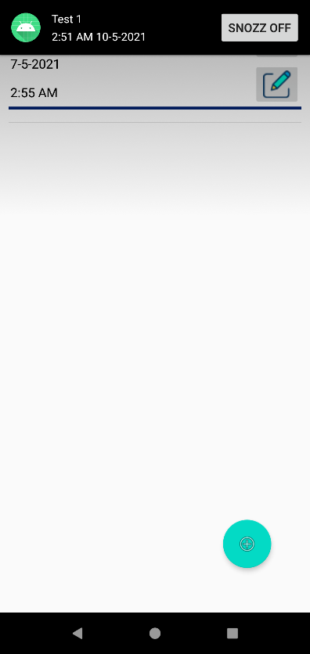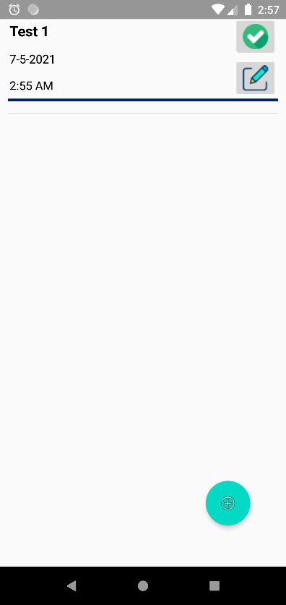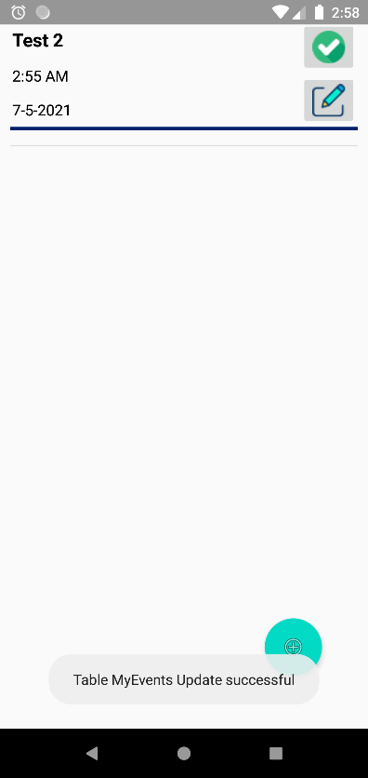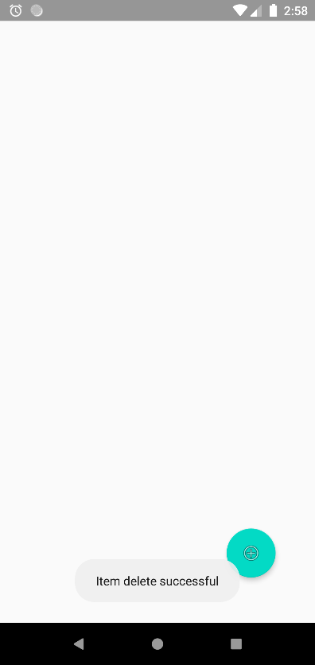

Figure 32 - Saving Reminders Test Cases

### 5.2.7 – Test case for Update Profile

Table 16 - Test Case seven Profile Update

|  |  |  |  |  |  |
| --- | --- | --- | --- | --- | --- |
| **Test Case Number:** 7 | | | | | |
| **Name:** User can update their user details | | | | | |
| **Precondition:** The user to has to login to the system | | | | | |
| **No.** | **Description** | **Inputs** | **Expected Result** | **Generated Result** | **Pass/Fail** |
| 6.1 | Update profile values | Name: Nimesh Mendis  Age: 25 | Successfully update values on profile as well as in the Realtime Database | Display a successful toast message “Profile updated Successfully” and change profile details in profile page and also in the Database | Pass |

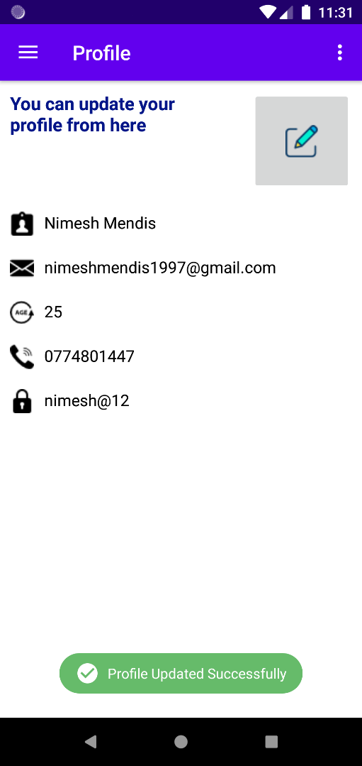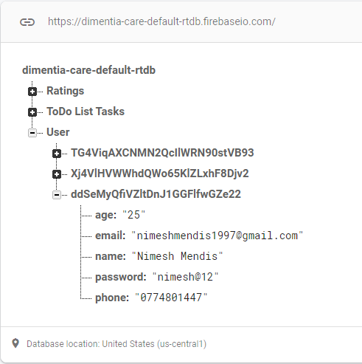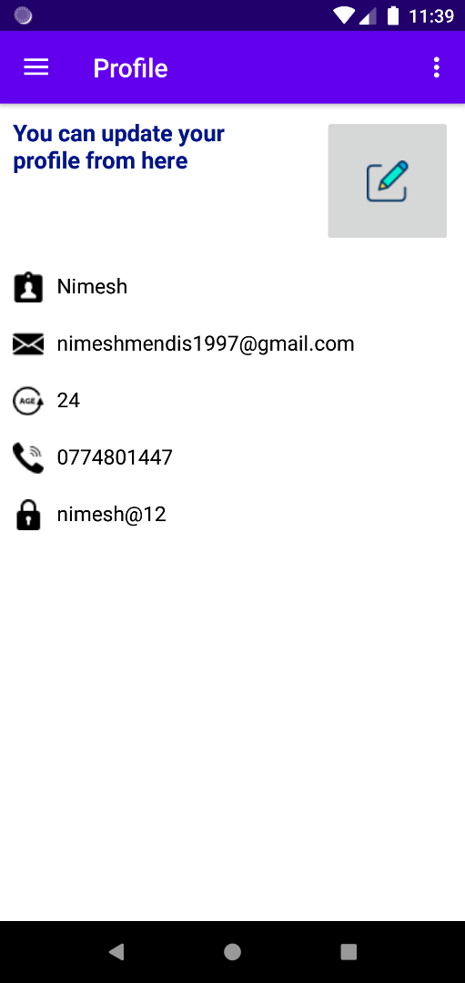

Figure 33 - Profile Update Test Cases

# Chapter Six – Conclusion

This final section of the study encompasses the whole paper. It also goes into the system's context, function, aims, and priorities, as well as its creation and ultimate usage for the last time. Perhaps the platform's advantages and disadvantages are also discussed below.

## 6.1 - Overview of the Project Background

Today people who are taking care of the persons with Dementia face lot of difficulties to how to look after their loved ones in situation like this. Due to increase of the Dementia problem care-takers or family members has to have an idea about. Non-pharmacological dementia treatment places a strain on caregivers who are caring for a patient with this lifelong illness. Caregivers are often called in to support their caregivers with everyday operations. They are, however, recommended to foster practical independence. Functional independence in persons with Dementia is enhanced and caregiver burden is reduced when a discrete tracking system is used. In this Thesis report discusses a method that uses smartphone apps to increase the efficiency of dementia patients' care. Mainly Dementia is related about the people who are have less brain functionalities and the researcher have to find any solution in technological side.

Since the evolution of technology there is no serious issue to find a solution application for Dementia. Since every user have a mobile application in their hands it is easy to develop a mobile application.

Dementia care health care application system provide users technologically advanced features as well as it provides users to have an idea about what is Dementia. Also, the application provides users to helping to recover their memory up to certain extent using a memory recall activity.

“DEMENTIA CARE” is a health care mobile application which is run on Android platform, the “Demibot” is the artificial intelligence chatbot plays a major role inside the application. User can have chat with bot and get help. “DEMENTIA CARE” application is unique from other applications because of this challenging component. Other than this feature there are features where helps user to recover their memory by recalling. As well as system provides music player which developed inside the application. Also provides song playlist which suitable for the user. All the songs which have been selected by the researcher are slow beat and mind soothing music. Additionally, the researcher adds features such as to-do list and reminder. User can be able to store their to-do activity tasks and reminders for their easy use.

The "DEMENTIA CARE" scheme was divided into stages in this thesis, which was then analysed and depicted to emphasize the system's importance. It was created after extensive study into memory recall behaviour, as well as an in-built music player and an AI chatbot. The planned project was designed and developed according to a comprehensive schedule. This contributed to the DEMENTIA CARE system's stable growth, which enabled it to meet its priorities and targets on time. Consumers will profit from this successful DEMENTIA CARE system by this system in their hectic lifestyle, which continues to overlook such problems and find solutions.

(The poster written for the project, which can be found in Appendix O, provides a brief outline of the project.)

## 6.2 - Benefits of the system

* Available free of charge
* User friendly and flexible
* Integrated AI chatbot
* System that store reminders and display notifications
* Memory recovery activities
* In build music player with a playlist

## 6.3 - Limitations of the System

Although the DEMENTIA CARE platform is a good addition to the field of technology, it does have certain limitations. Developers have a responsibility to recognise their system's constraints and have fast solutions for them. The below are some of the shortcomings found within the “DEMENTIA CARE” scheme.

* The system is only limited in the English language due to a lack of overall language literacy.
* Now, it is just a mobile application, although it can be adapted for other platforms in the future.
* Problems occurred in chatbot due to insufficiency of knowledge and training
* The application is only developed for Android OS users, since it has not yet been developed for IOS devices.
* Access to applications is restricted where there is no or a weak internet service.

## 6.4 - Lessons Learned

During the development process, a significant amount of information, expertise, and experience was accumulated. The proposed system's activities were defined and separated into parts to make the development process easier. Completing each chunk in the allotted time was difficult, and with each chunk completed, I acquired more and more personal development. The proposed framework had a steep learning curve, and I had no previous experience with mobile application development, by searching on internet for codes for development and find for solutions for problems during development stage. It is great an opportunity to learn new languages and frameworks. Important part of this research is to have a good connection with the users and understand their requirements before developing the system. More importantly time management was a big challenge to develop this project for a project plan, as the researcher it is need to work on time and it is an essential factor in this research.

## 6.5 - Future Work

As for the future proposed system, the researcher needs to enhance the overall features which has developed in the system and finalize the application with improvements. Lack of updated knowledge in chatbot of the DEMENTIA CARE application is one of a major cons. For future work the researcher going to update the knowledge of the bot and train the bot to improve the accuracy and the reliable Demibot.

Enhance the memory recall activity and the implementing the identify object activity for the users to help them to recover their memory.

Another major feature is going to implementing is user can have ability to store their memories such as their recordings, their images and other memorable items inside the application and user can have ability to look at them and recover their memories.

Apart from the chatbot, the researcher going to develop an another algorithm to find the stage of Dementia that user currently staying by answering questions and analyse the answers and predict the result

# References

Anderson, J.G., Rose, K.M. and Taylor, A.G., 2016. A descriptive study of the nutrition-related concerns of caregivers of persons with dementia. Journal of Aging Research and Clinical Practice, 5(1), pp.1-6.

Bateman, D.R., Srinivas, B., Emmett, T.W., Schleyer, T.K., Holden, R.J., Hendrie, H.C. and Callahan, C.M., 2017. Categorizing health outcomes and efficacy of mHealth apps for persons with cognitive impairment: a systematic review. Journal of medical Internet research, 19(8), p.e301.

Blom, M.M., Zarit, S.H., Zwaaftink, R.B.G., Cuijpers, P. and Pot, A.M., 2015. Effectiveness of an Internet intervention for family caregivers of people with dementia: results of a randomized controlled trial. PloS one, 10(2), p.e0116622.

Brooke, J., 2016. Caring for patients with dementia. *Nursing in Practice*, *89*, pp.68-71.

Davis, B., Nies, M., Shehab, M., Shenk, D. and Alfonzo, P., 2014. Developing a pilot e-mobile app for dementia caregiver support: Lessons learned. Online Journal of Nursing Informatics (OJNI), 18(1).

Grossman, M.R., Zak, D.K. and Zelinski, E.M., 2018. Mobile apps for caregivers of older adults: Quantitative content analysis. JMIR mHealth and uHealth, 6(7), p.e162.

Guo, Y., Yang, F., Hu, F., Li, W., Ruggiano, N. and Lee, H.Y., 2020. Existing Mobile Phone Apps for Self-Care Management of People With Alzheimer Disease and Related Dementias: Systematic Analysis. JMIR aging, 3(1), p.e15290.

Halbach, T., Solheim, I., Ytrehus, S. and Schulz, T., 2018. A Mobile application for supporting dementia relatives: a case study. Studies in health technology and informatics, 256, pp.839-846.

Imtiaz, D., Khan, A. and Seelye, A., 2018. A mobile multimedia reminiscence therapy application to reduce behavioral and psychological symptoms in persons with Alzheimer’s. Journal of healthcare engineering, 2018.

Kabir, Z.N., Leung, A.Y.M., Grundberg, Å., Boström, A.M., Lämås, K., Kallström, A.P., Moberg, C., Cronfalk, B.S., Meijer, S. and Konradsen, H., 2020. Care of family caregivers of persons with dementia (CaFCa) through a tailor-made mobile app: study protocol of a complex intervention study. BMC geriatrics, 20(1), pp.1-7.

Kernebeck, S., Holle, D., Pogscheba, P., Jordan, F., Mertl, F., Huldtgren, A., Bader, S., Kirste, T., Teipel, S., Holle, B. and Halek, M., 2019. A tablet app–and sensor-based assistive technology intervention for informal caregivers to manage the challenging behavior of people with dementia (the insideDEM study): protocol for a feasibility study. JMIR research protocols, 8(2), p.e11630.

Klimova, B., 2017. Mobile phone apps in the management and assessment of mild cognitive impairment and/or mild-to-moderate dementia: an opinion article on recent findings. Frontiers in human neuroscience, 11, p.461.

Lancioni, G.E., Singh, N.N., O’Reilly, M.F., Sigafoos, J., D’Amico, F., Turnone, B., Laporta, D., Scordamaglia, A. and Pinto, K., 2019. Smartphone-based interventions to foster simple activity and personal satisfaction in people with advanced Alzheimer’s disease. American Journal of Alzheimer's Disease & Other Dementias®, 34(7-8), pp.478-485.

Moussa, Y., Mahdanian, A.A., Yu, C., Segal, M., Looper, K.J., Vahia, I.V. and Rej, S., 2017. Mobile health technology in late-life mental illness: a focused literature review. The American Journal of Geriatric Psychiatry, 25(8), pp.865-872.

National Collaborating Centre for Mental Health (UK, 2007. Dementia. In Dementia: A NICE-SCIE Guideline on Supporting People With Dementia and Their Carers in Health and Social Care. British Psychological Society.

O'Connor, E., Farrow, M. and Hatherly, C., 2014. Randomized comparison of mobile and web-tools to provide dementia risk reduction education: use, engagement and participant satisfaction. JMIR Mental Health, 1(1), p.e4.

Rathnayake, S., 2019. Co-design of an mHealth application for family carers of people with dementia to address needs related to the functional disability of their care recipients.

Rathnayake, S., Moyle, W., Jones, C.J. and Calleja, P., 2019. Development of an mHealth application for family carers of people with dementia: A study protocol. Collegian, 26(2), pp.295-301.

Reyes, A.K., Camargo, J.E. and Díaz, G.M., 2015, November. Design of a mobile application to support non-pharmacological therapies for people with alzheimer disease. In ICSH (pp. 321-332). Springer, Cham.

Sikder, A.T., Yang, F.C., Schafer, R., Dowling, G.A., Traeger, L. and Jain, F.A., 2019. Mentalizing imagery therapy mobile app to enhance the mood of family dementia caregivers: feasibility and limited efficacy testing. JMIR aging, 2(1), p.e12850.

Sindi, S., Calov, E., Fokkens, J., Ngandu, T., Soininen, H., Tuomilehto, J. and Kivipelto, M., 2015. The CAIDE Dementia Risk Score App: The development of an evidence‐based mobile application to predict the risk of dementia. Alzheimer's & Dementia: Diagnosis, Assessment & Disease Monitoring, 1(3), pp.328-333.

Vuong, N.K., Goh, S.G.A., Chan, S. and Lau, C.T., 2013, July. A mobile-health application to detect wandering patterns of elderly people in home environment. In 2013 35th Annual International Conference of the IEEE Engineering in Medicine and Biology Society (EMBC) (pp. 6748-6751). IEEE.

WebMD. 2020. What Is Dementia?. [online] Available at: <https://www.webmd.com/alzheimers/types-dementia#1> [Accessed 3 December 2020].

Yousaf, K., Mehmood, Z., Saba, T., Rehman, A., Munshi, A.M., Alharbey, R. and Rashid, M., 2019. Mobile-health applications for the efficient delivery of health care facility to people with dementia (PwD) and support to their carers: a survey. BioMed research international, 2019.

Zwingmann, I., Michalowsky, B., Esser, A., Kaczynski, A., Monsees, J., Keller, A., Hertel, J., Wucherer, D., Thyrian, J.R., Eichler, T. and Kilimann, I., 2019. Identifying unmet needs of family dementia caregivers: results of the baseline assessment of a cluster-randomized controlled intervention trial. Journal of Alzheimer's Disease, 67(2), pp.527-539.

# Appendix

## Appendix A

*‘A disorder because of illness of the cerebrum, as a rule of a persistent or reformist nature, where there is the unsettling influence of different higher cortical capacities, including memory, thinking, direction, cognizance, figuring, learning ability, language, and judgment. Awareness is not impeded. Weaknesses of intellectual capacity ordinarily go with, periodically went before, by weakening in enthusiastic control, social conduct, or inspiration. The disorder happens in Alzheimer's infection, in cerebrovascular sickness, and in different conditions basically or optionally influencing the mind’ (National Collaborating Centre for Mental Health UK, 2007).*

Dementia results from an assortment of illnesses and wounds that essentially or optionally influence the mind, for example, Alzheimer's sickness or stroke *(World Health Organization, 2012).* Dementia is one of the significant reasons for incapacity and reliance among more seasoned individuals around the world. It tends to be overpowering, for the individuals who have it as well as for their care takers and families. There is regularly an absence of mindfulness and comprehension of dementia, bringing about criticism and hindrances to finding and care. The effect of dementia on care takers, family and society everywhere can be physical, mental, social, and monetary *(World Health Organization, 2012)*.

Individuals with dementia are bound to have at least five medical issues and more solution use than those without dementia *(Clague F, Mercer SW, McLean G, Reynish E, Guthrie B, 2017)*,and co-dreariness going from two to eight conditions has been accounted for *(Schubert CC, Boustani M, Callahan CM et al, 2006).*

Dementia is an overall medical care challenge. As per the assessments of Alzheimer Disease International, there were around 35.6 million individuals with dementia in 2010, a number that will almost be twofold to 65.7 million by 2030 and fourfold to 115.4 million by 2050 *(World Health Organization, 2012)*.

## Appendix B

known as neurodegenerative disorders such as, Alzheimer’s, levy body Dementia and stroke. Since this is not a medical research, the researcher only going to explain about the Alzheimer’s disease.

**Alzheimer’s disease**

which is the most well-known type of dementia among more seasoned individuals. Individuals with Alzheimer's have plaques and tangles in their cerebrum. These are irregular developments of various proteins. Beta-amyloid protein bunches up and frames plaques in the middle of your synapses. Tau protein develops and frames tangles inside the nerve cells of your cerebrum. There is likewise a deficiency of association between nerve cells in the mind *(U.S. National Library of Medicine, 2020).*

## Appendix C

Analysts have found various qualities that expansion the danger of building up Alzheimer's sickness. Although individuals with a family background of Alzheimer's infection are commonly viewed as at an uplifted danger of building up the illness themselves, numerous individuals who have family members with Alzheimer's sickness never build up the infection, and numerous without a family background of the sickness do get it *(Stanford health care, 2020)*. Following are some of the factors causing Dementia given down below.

The most widely recognized reasons for dementia include:

* Degenerative neurological infections. These incorporate Alzheimer's illness, Parkinson's infection, Huntington's sickness, and a few sorts of numerous sclerosis. These illnesses deteriorate over the long run.
* Vascular issues. These conditions influence the blood course in your mind.
* Horrendous cerebrum wounds brought about via auto crashes, falls, blackouts, and so on
* Contaminations of the focal sensory system. These incorporate meningitis, HIV, and Creutzfeldt-Jakob sickness.
* Long-term liquor or medication use
* Specific sorts of hydrocephalus, development of liquid in the cerebrum

Certain physical and way of life variables can put you at higher danger of having dementia, including:

* **Maturing. This is the greatest danger factor for dementia.**

Your body goes through numerous progressions with maturing. As grown-ups age, some may encounter typical age-related changes in memory and thinking. Dementia, or extreme cognitive decline that meddles with day-by-day life, is not important for the typical maturing measure *(Centers for disease control and prevention, 2020).*

* **Smoking**

There is solid proof that smoking can build your danger of creating dementia. Not every person who smokes will get dementia, but rather halting smoking is thought to decrease your danger down to the degree of non-smokers.

It is realized that smoking builds the danger of vascular issues, including through strokes or more modest seeps in the cerebrum, which are additionally hazarded factors for dementia. What is more, poisons in tobacco smoke increment oxidative pressure and aggravation, which have both been connected to creating of Alzheimer's sickness.

* **Uncontrolled diabetes**

Diabetes can cause a few complexities, for example, harm to your veins. Diabetes is viewed as a danger factor for vascular dementia. This kind of dementia happens because of cerebrum harm that is frequently brought about by diminished or impeded bloodstream to your mind *(Mayo clinic staff, 2019).*

* **Hypertension**

Hypertension is a persistent condition that causes reformist organ harm. It is notable that by far most of the instances of Alzheimer's sickness and related dementia are not because of hereditary inclination yet rather to constant presentation to vascular danger factors *(Oxford University Press USA, 2018).*

* **Drinking a lot of liquor**

Unnecessary liquor utilization throughout a protracted timeframe can prompt mind harm and may expand your danger of creating dementia. In any case, savouring liquor control has not been indisputably connected to expanded dementia hazard, nor has it been appeared to bring to the table huge security against creating dementia.

* **Having close relatives who have dementia** *(U.S. National Library of Medicine, 2020).*

Alzheimer's sickness and different dementias have a profound effect on the individuals who are analysed, yet additionally on the individuals who are nearest to them. Relatives need to take on various obligations when a relative is determined to have dementia. Children and girls of a parent with dementia may become guardians and married couples of the individual with dementia see their jobs change. They regularly end up in the part of essential guardian.

## Appendix D

1. **No impairment**. Somebody at this stage will show no side effects, however, tests may uncover an issue.
2. **Very mild decline**. You may see slight changes in conduct, however, your cherished one will even now be free.
3. **Mild decline**. You will see more changes in their reasoning a lot. They may have trouble planning, and they may rehash themselves a great deal. They may likewise struggle to recall late occasions.
4. **Moderate decline**. They will have more issues with planning and recollecting ongoing occasions. They may struggle to voyage and dealing with cash.
5. **Moderately severe decline**. They may not recollect their telephone number or their grandkids' names. They might be befuddled about the hour of day or day of the week. Now, they will need help with some essential everyday capacities, for example, choosing garments to wear.
6. **Severe decline**. They will start to fail to remember the name of their mate. They will require help heading off to the bathroom and eating. You may likewise observe changes as a part of their character and feelings.
7. **Very severe decline**. They can presently do not talk their contemplations. They cannot walk and will spent much of their energy in bed *(Brunilda Nazario, WebMD 2020).*

According to the World Health Organization, Dementia influences every individual in an alternate manner, contingent on the effect of the illness and the individual's character prior to getting sick. The signs and manifestations connected to dementia can be perceived in three phases. According to their categorization they named stages as; **Early stage, Middle stage, and Late stage** *(World Health Organization, 2012)*.

## Appendix E

A determination of dementia can hugely affect an individual's life. Somebody as of late determined to have dementia is probably going to encounter a scope of feelings. These may incorporate sadness, misfortune, outrage, stun, dread, mistrust and even help. Living with dementia presents numerous difficulties for individuals with dementia and for the individuals who care for them. This might be combined with other medical issues as the gathering of changes related to maturing can prompt the accumulation of sicknesses and handicaps *(Yancik R, Ershler W, Satariano W, Hazzard W, Cohen HJ, Ferrucci L, 2007).*

A few people may battle to manage these feelings and they may move between feelings as they change. They may feel apprehensive about the future, frightened about snapshots of disarray and carelessness, and upset about the effect dementia has on everyone around them. The affirmation of a determination may trigger melancholy and uneasiness in certain individuals. There are various talking treatments and - if necessary - drug medicines accessible for discouragement and nervousness. Way of life changes can help as well *(alzheimers.org.uk, 2020).* Dementia can be overpowering for the groups of influenced individuals and for their care takers. Physical, enthusiastic, and monetary weights can make extraordinary pressure families and care takers, and backing is needed from the wellbeing, social, monetary, and overall sets of laws *(World Health Organization, 2012).* Furnishing care to a relative with dementia, nonetheless, is frequently a distressing encounter that can disintegrate the psychological and actual strength of the guardian. Parental figures create sensations of weight as well as show more elevated levels of mental indications, burdensome and tension problems, more unfortunate safe capacity, and even a higher passing danger contrasted with non-guardians of everybody *(World Health Organization, 2012).*

At times, the activities, and articulations of an individual living with dementia are 'practices' that are disturbing, testing and going up against. These 'practices' are regularly viewed as brought about by the illness, a manifestation of dementia. Sadly, they are regularly overseen utilizing a drug, restriction, separation, and a dismissal for the individual as a person *(alzheimerswa.org.au, 2019).* Individuals with dementia regularly experience changes in their passionate reactions. They may have less power over their sentiments and how they express them. For instance, somebody might be bad-tempered, or inclined to quick temperament changes or blowing up to things. They may likewise show up surprisingly uninterested in things or far off *(alzheimers.org.uk, 2020).*

There are around 670,000 relatives and companions giving most consideration to individuals with dementia in the United Kingdom. Together, these guardians are assessed to give 1.3 billion hours of care for each year and spare the UK economy £12 billion yearly *(Alzheimer's Society. Dementia UK update, 2014)*. Without the assistance of such parental figures, the conventional consideration framework would probably implode *(Alzheimer's Society, Carer support, 2013).*

## Appendix F

Dementia is probably the greatest test in medical services around the world. It impacts people, their families and companions, guardians, and society *(Alzheimer’s Society, 2009).* Additionally, the visits of outpatients with a memory problem in specific medical care are rising each year *(National Institute for Health and Welfare, 2011).* The current framework, which is centered around intense consideration, is ill-equipped to offer to organize care for more established individuals in various consideration conditions *(Nina Hynninen, Reetta Saarnio, Satu Elo, 2016).* Further *Nina Hynninen (2016)* according to the estimates a fourth of emergency clinic beds are involved by individuals with dementia over the time of 65 years *(Alzheimer’s Society, 2009).* Patients older than 65 years go through over 55% of all surgeries performed. Hospitalized individuals with dementia have expanded danger of enduring ridiculousness, falls, parchedness, and untreated torment *(Cohen-Mansfield, J, Thein, K, Marx, MS, 2012).* Hence, the nursing staff thinking about individuals with dementia need preparing in managing this patient gathering. The preparation needs incorporate correspondence, overseeing fomentation, sustenance, and cleanliness *(Weitzel, T, Robinson, S, Barnes, MR, 2011).*

Dementia directing is dementia care that fixes physiologically insecure circumstance of an individual with dementia, through responsive and mindful discussions. An individual with dementia ought to get the directing as regularly as could be expected under the circumstances. Nonetheless, it is hard for a predetermined number of guardians to save adequate time and exertion *(Seiji Sakakibara, Sachio Saiki, Masahide Nakamura, 2017).* According to *Seiji Sakakibara (2017)* they inspiring to misuse the virtual specialist innovation they are creating, for executing everyday dementia directing framework at home.

Since most types of dementia cannot be restored, the focal point of treatment is to give satisfactory consideration. Present-day approaches endeavour to zero in on the necessities of patients, for example, assisting them with keeping up psychological working, the capacity to perform ordinary assignments, and personal satisfaction for to the extent that this would be possible *(Nina Rieckmann, Christoph Schwarzbach, 2009)*.

## Appendix G

Tension can influence individuals with indications of dementia, particularly in the beginning phases of the illness, as they initially understand their deficiency of memory and declining intellectual capacities. There is a lot that guardians can never quiet their friends and family. Not every one of them will work in each condition, or with each person, tolerance and an experimentation approach might be ideal *(blog.thebristal.com)*.

The individuals who experience the ill effects of dementia are normally burdened by uneasiness and fits of anxiety. This can be particularly pervasive in the beginning incredibly to holds with their intellectual decrease. As a guardian, companion, or relative, this can be hard to observe, however, there are a few things that you can do to assist them with getting on edge periods *(kadmin, angelsseniorliving.com, 2018).* According to kadmin (2018) there are five activities that care takers can do with the people with Dementia. These activities are as follows.

* **Breathing Exercises** – It might appear cliché, yet controlled profound breathing is one of the most broadly supported activities for quieting seniors with dementia. Profound breathing is finished by growing the stomach to completely fill the lungs and really prompts an unwinding reaction in the mind. Shallowed, froze breathing can really deliver pressure hormones into the body.
* **Outdoors** – Try taking moderate, easy-going strolls outside when your cherished one feels somewhat on edge. The outside climate and change of view can go about as a loosening up redirection and will help remove their brain from the uneasiness source. Other outside exercises, for example, planting, are likewise incredible sources to consider.
* **Brain Exercises** – Cognitive activities are extraordinary approaches to keep the cerebrum dynamic and not pondering tension triggers. Exercises, for example, messing around, having drawing in conversations, or in any event, playing on the PC can help.
* **Tai Chi or Yoga** – As long as these exercises are inside the actual abilities of people with Dementia, yoga and tai chi can help facilitate the psyche and body and can help advance unwinding.

**Music** – Listening to the senior's favourite music or just for the most part quieting music is an extraordinary method to help facilitate their sense of panic.

## Appendix H

Music treatment is characterized by the World Federation of Music Therapy as the utilization of music and additionally its melodic components (sound, mood, tune and amicability) by a certified music specialist, with a customer or gathering, in a cycle intended to encourage and advance correspondence, connections, learning, activation, articulation, association and other pertinent helpful targets to meet physical, passionate, mental, social and psychological necessities *(World Federation of Music Therapy, 2010)*.

Two fundamental sorts of music treatment can be recognized: receptive and active music treatment. Receptive music treatment comprises of tuning in to music by the advisor who sings or chooses recorded music for the beneficiaries. Active music treatment, beneficiaries are effectively engaged with the music‐making by playing for example on little instruments. The members might be urged to take an interest in melodic spontaneous creation with instruments or voice, with dance, development exercises or singing. Music specialists need the abilities of the two artists and advisors on the off chance that they are to profit insane individuals. Music advisors must be prepared to choose and apply melodic boundaries sufficiently, custom-made to a patient's necessities and objectives *(Annemiek C VinkManon S BruinsmaRob JPM Scholten, 2003)*.

## Appendix I

At the point when individuals keep their brains dynamic, their reasoning abilities are less inclined to decay, clinical examination shows. Games, puzzles, and different kinds of mind preparing may help moderate cognitive decline and other mental issues *(WebMD, 2010)*. Further WebMD (2010) explain in their journal about one research study was done by a researcher included more than 2,800 adults 65 and elder. They went if 10 hour-long mind instructional meetings for 5 to about a month and a half. The meetings zeroed in on strategies for these aptitudes:

* Memory
* Reasoning
* Speed of processing information

Individuals who took the preparation indicated improvement in these aptitudes that went on for at any rate 5 years. They additionally improved at regular undertakings, for example, the capacity to oversee cash and do housework *(WebMD, 2010)*.

## Appendix J

* Schedule

This feature provides daily activities which is doing by the persons with Dementia. In this check list user can add or remove check mark daily activities which is doing by persons with dementia in a day such as breakfast, lunch, dinner, etc. User can get an idea about the person with his daily activity. System also provide facility to add new tasks to the list such as giving injections, giving tablets or medicine.

* Daily function

This function provides daily health measures like vital sign, temperature, and weight. By entering daily figures user can hunt the development or worsen of the person with Dementia.

* Behaviour

Under this feature system provides sort of moods and behaviour of an individual with Dementia showing. Each mood or behaviour system includes sub parts to which supplies a rate. If an individual shows such behaviour user can select the category and answer the subsequent inquiries to system to analyse.

* Notes

System provides notes function to feature notes to user to easy their tasks and remind them what to try and do in future.

## Appendix K

* + Dementia risk test
  + Disease information
  + Option to send test results via email.
  + Next test date reminders
  + Tips and tricks to cut back Dementia.
  + Sharing options

## Appendix L

* Brain workouts

Developers designed scientifically – supported suite of games to challenge four abilities and enhanced critical thinking skills.

* Problem solving
* Speed
* Memory
* Attention
* Nutrition

System provide advices to assist users to form healthier choices among various nutritious dishes.

* TV and Music

System provides an entertainment section vast video content and musical style, and films belongs to 40’s, 50’s, 60’s, 70’s, 80’s.

* My Diary

In here user can store their memories share and relieve with their family and friends.

* Reminders

User can make notes, to-do lists and customizable reminders during this system.

## Appendix M

* + Top ten indications of Alzheimer's sickness.
  + Latest data on the discovery, analysis, and the executives of Alzheimer's sickness.
  + Interactive devices like clock drawing test, Saint Louise University Mental Status Exam and Functional exercises survey.
  + Email administrations which give instructive and uphold data to the clients.

## Appendix N

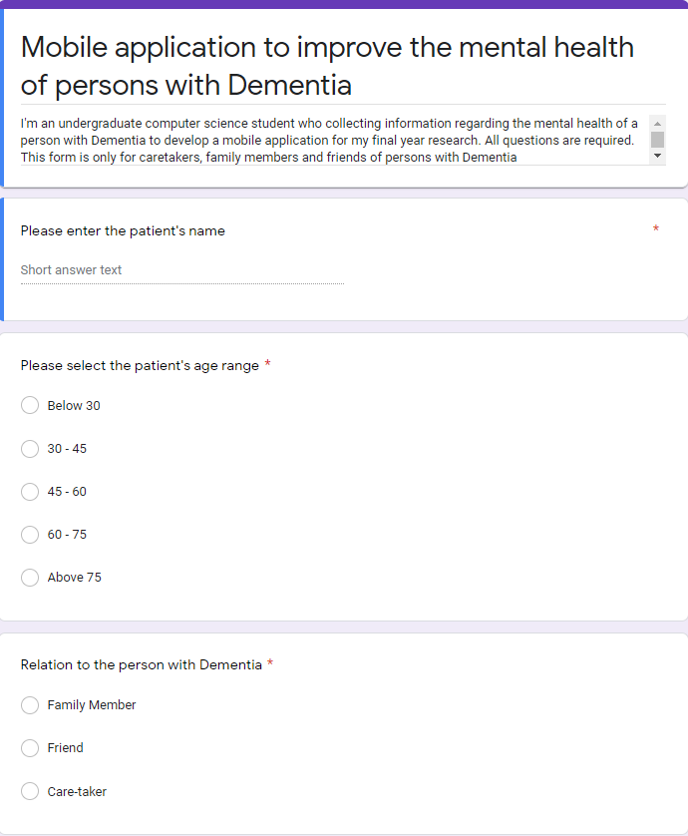

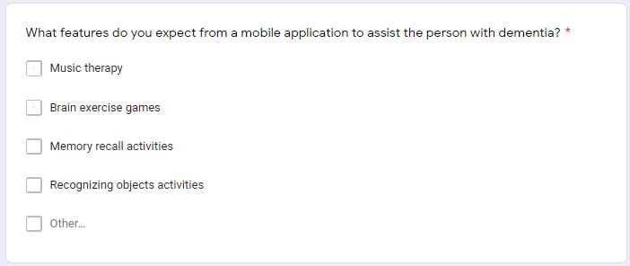

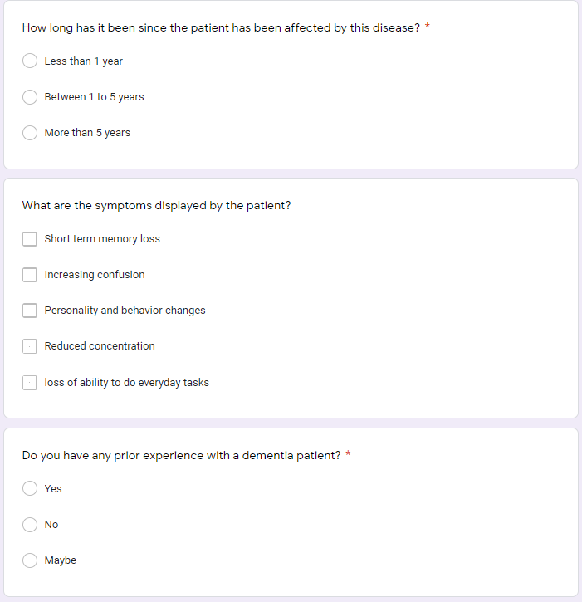

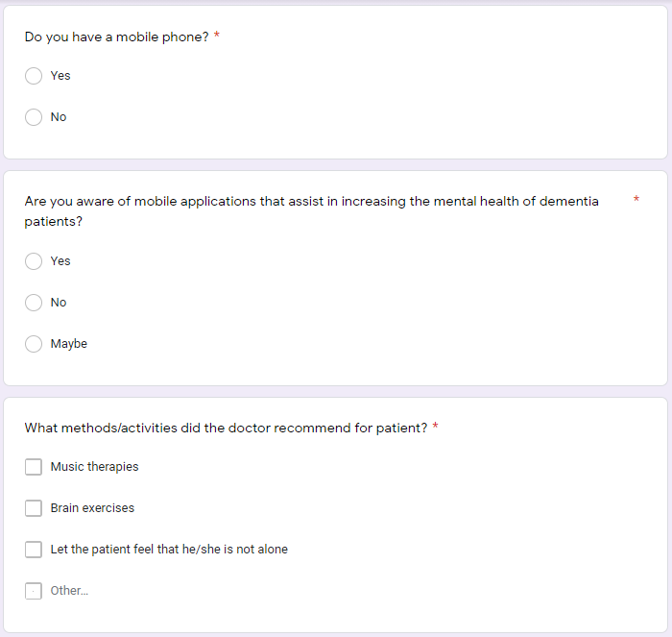

## Appendix O

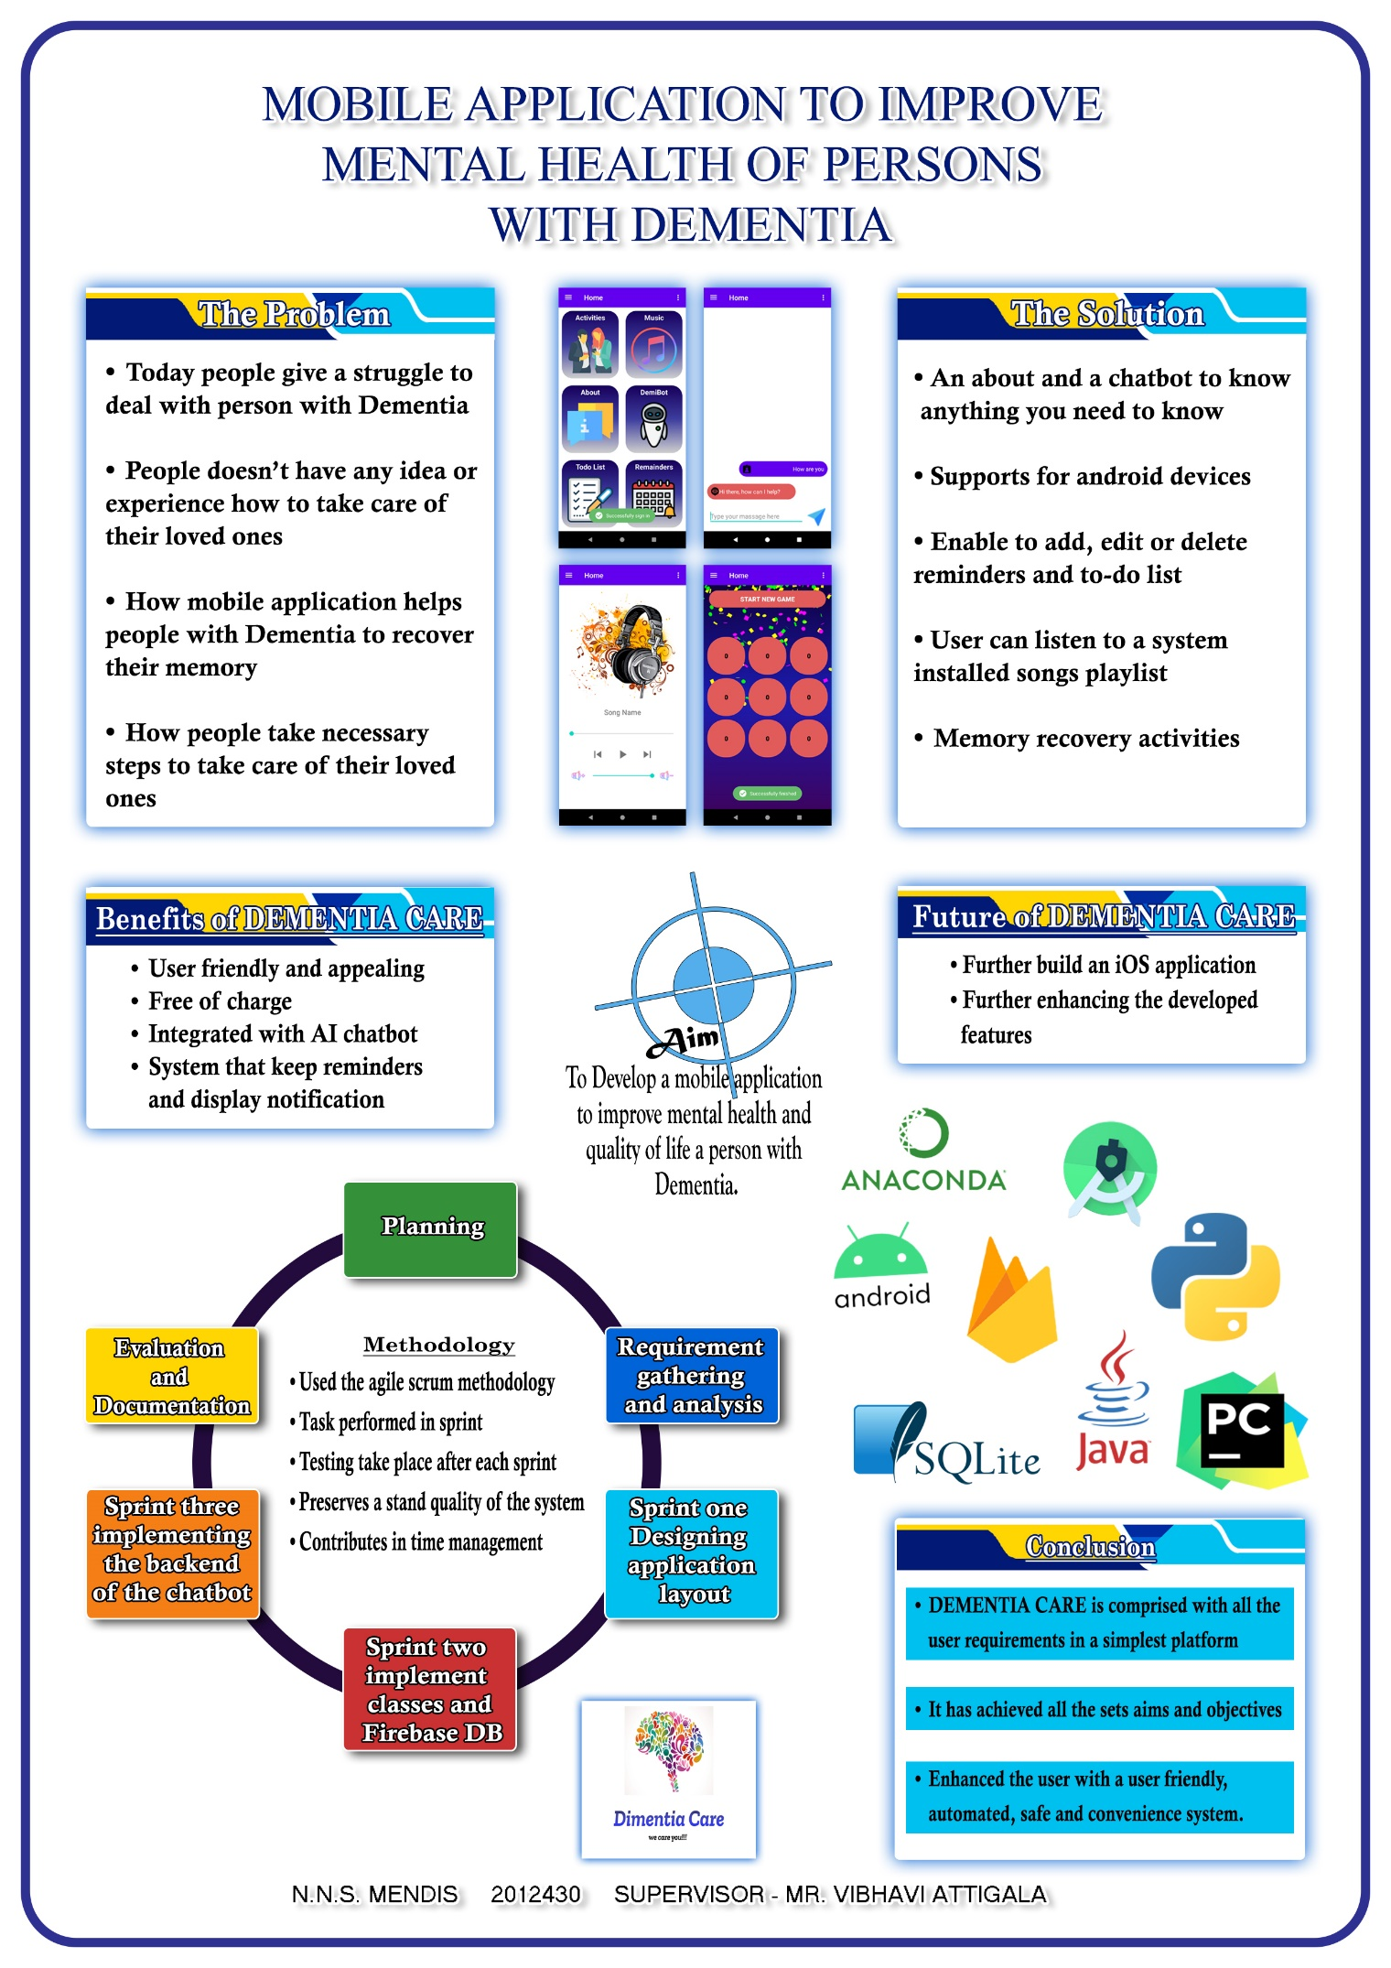

Figure 34 - Project Poster